Determining the Impact of Xfinity on Demand Video Supplements on Learning 6th Grade Science

June 2011

Principal Investigator:
Jennifer C. Richardson, Ph.D.

Assisted by:
Taeho Yu (Lead), Kadir Kozan, Larisa A. Olesova, Adrie Koehler

Learning Design and Technology Program
College of Education
Purdue University

100 N. University Street,
West Lafayette, IN 47906-2098
(765) 494-5669

Determining the Impact of Xfinity on Demand Video Supplements on Learning for 6th grade Science Students

EXECUTIVE SUMMARY

Three pretest/posttest measures were provided to all students, in both the control (n=454) and the experimental group (n=58): The Views of the Nature of Science Survey (VNOS), a Standards-based Content Survey, and the Patterns of Adaptive Learning Scales Survey (PALS). One post-test measure, containing open-ended questions, was provided to the experimental group. Other information was obtained from student video logs completed by those within the experiential group and by breaking students within the experimental group into high and low usage groups based on the number of videos they indicated watching (1-5, 6 or more)

Noteworthy Open-ended Posttest Question Results (n=99)
- 80% of students in experimental group responded, with 32.9% of students indicating they watched 11 or more videos.
- More than 80% of students in experimental group had positive feedback related to the Xfinity science videos, describing them as “Fun”, “Interesting”, “Easy to understand/follow”, “Cool/good”, and “Educational”. The majority of responses, 35% of students, described the Xfinity science videos as “Helpful”.
- Perhaps most importantly, 64% of students in the experimental group thought that the Xfinity science videos helped them to do better on their ISTEP science test.

Noteworthy Standards-based Content Survey Results
- The experimental group outperformed the control group on 4 of the 6 standards assessed at two or more sites. Specifically:
  - Standard One: The Experimental group outperformed the control group on standard one at Frankfort MS and Wabash MS.
  - Standard Four: The Experimental group did better than the control group on standard four at Tuttle MS and Frankfort MS.
  - Standard Five: The Experimental group outperformed the control group for standard five at Tuttle MS and Wabash MS.
  - Standard Six: The Experimental group outperformed the control group on Standard 6 across all three schools (Northridge MS is a control school).
  - At Tuttle MS in particular, the experimental group outperformed the control group.
- However, there was a significant pretest score difference across schools for all standards. Further analyses also showed that student scores had a tendency to change significantly across different teachers. As a result, the findings should be read carefully due to the performance differences across schools and teachers and should be kept in mind when interpreting the results.

Noteworthy PALS Survey Results
- The experimental group outperformed the control group on several of the PALS scales or sections assessed at two or more sites. Specifically:
  - Overall the experimental group outperformed the control group at Tuttle MS and Frankfort MS.
  - Performance Approach Goal: The experimental group outperformed the control group across all three experimental schools consistently.
  - Mastery Goal: The experimental group outperformed the control group at Tuttle MS and Wabash MS.
  - Avoiding Novelty: Experimental group outperformed the control group at Frankfort MS and Wabash MS.
- It should also be noted that parts of the PALS survey students` ratings on academic efficacy, mastery goal and willingness to do new class work differed significantly across teachers, which could have also impacted the results.

Noteworthy VNOS Results
- Concerning each VNOS question, the control group achieved higher scores on more post VNOS questions than did the experimental group. However, for VNOS item 1 the experimental group consistently outperformed the control group (e.g. tools used by scientists) across all 3 experimental schools. Additionally, the experimental group outperformed the control group consistently at Frankfort MS across items.
- Combined across several statistical analyses we found that irrespective of their experimental group, students achieved significantly different scores on post VNOS test but this increased performance also changed significantly across teachers. This result indicates that the significant performance increase of the control group may have stemmed from teacher differences, possibly content covered or teaching styles/methods.

TABLE OF CONTENTS

Page

Background/Participants

- Experimental vs. Control Group Participants 1
- Breakdown of Participants by Schools 1

Views of the Nature of Science (VNOS) Survey

- Overall scores by School 2
- Results by School and Item 3
- Patterns Analysis for VNOS 7
- Inferential Statistics for VNOS 9

Standards-Based Content Survey

- Overall Pretest and Posttest Scores by School 13
- Overall Pretest and Posttest Scores by School and Standard 14
- Patterns Analysis for Content survey 17
- Inferential Statistics for Content survey 18

PALS Survey Results

- Overall Pretest and Posttest Scores by School 21
- Overall Pretest and Posttest PALS Scores By School and Categories 22
- Patterns Analysis for PALS 25
- Inferential Statistics for PALS 26

Student Open-ended Questions for Post-test

- Graphs and Summary Tables for Survey Items 29

Sample Student Responses from Video Logs 37

References 41

Appendix A: Pretest/Posttest Student Surveys 42

Appendix B: Open-ended Posttest for Experimental Students 52

Appendix C: School Demographic Data and Comparisons 54

BACKGROUND/ PARTICIPANTS

Overview for All Participants

644 students from 4 different schools participated in this study. However, we only counted 512 students for the data analyses in this paper because there are some students missed either pre-survey or post-survey and we only included students who took both pre-survey and post-survey for the data analyses.

- Experimental vs. Control Group Participants

A total of 99 experimental or “home” participation students, 103 “library” participation students, and 442 control group students were recruited for the study. The participants were from 4 different school districts within Indiana. However, following initial analyses of the data and data cleaning processes only 58 students remained in the experimental group; all “library” students were moved to the control group based on the following criteria:

Experimental group: students in experimental group 1) must have watched at least one Xfinity VOD for 6 grade science, and 2) participated in both the pre-survey or post-survey process.

Experimental Group | Control Group
58 | 454

- Breakdown of Participants by School

 | Experimental Group | Control Group | Total Participants
Joseph F Tuttle | 24 | 131 | 155
Northridge* | 0 | 100 | 100
Frankfort | 15 | 160 | 175
Wabash | 19 | 63 | 82
Total | 58 | 454 | 512
* Northridge had 6 home participating students but because they did not indicate they watched any videos they were moved to the control group; all students in Northridge were placed within the control group.

Note: Additional School data including enrollments, free/reduced lunch percentages, median income, and previous ISTEP scores for 7th grade science, 6th grade math and 6th grade language Arts available in Appendix B.
Views of the Nature of Science (VNOS) SURVEY

VNOS (Views of the Nature of Science) Survey, version E was provided as a pre and post-test assessment for all participants. The VNOS survey is designed to assess students’ understandings that science is tentative, involves human creativity and subjectivity, necessarily involves both observation and inference, is not limited to a single approach, and is, at some point, empirically-based (Norm, Fouad, Randy, & Rene´e, 2002). Scoring of answers in VNOS survey is not meant to yield a numerical value, but rather a description of whether the respondent has the desired view. Additionally, the VNOS survey allows students draw pictures to help explain their ideas; complete sentences are not required.
- There is no right or wrong answer for each question within the VNOS survey. The researcher is only interested in students’ ideas about the questions in VNOS survey.
- Students’ views of NOS aspects are categorized into naïve, transitional, or informed based on the following criteria:

- No answer:
- Naïve: Student’s/Teacher’s response is not consistent with any part of NOS aspect.
- Transitional: Student’s/Teacher’s response is consistent with some, but not all, parts of NOS aspect.
- Informed: Student’s/Teacher’s response is consistent and addresses ALL parts of NOS aspect.

To View the survey items please refer to Appendix A.

VNOS Survey Results

- Overall Scores by School
(Note: All Northridge middle school students were in the control group.)

- We divided the experimental group into high and low usage groups to measure the effect of usage variable.
- Based on Xfinity usage data and student logs, if a student watched more than 5 videos, the student clarified as high usage group. In the other hand, if a student watched less than 5 videos, the student clarified as low usage group.

Joseph F Tuttle |  |  | Pre VNOS Survey |  |  | Post VNOS Survey |  |  | Mean Difference (Post-Pre)
 |  |  | N | Mean | SD | N | Mean | SD
Overall |  |  | 155 | 11.45 | 2.18 | 155 | 13.17 | 4.91 | 1.72*
Experimental Group |  |  | 24 | 12.29 | 2.12 | 24 | 13.42 | 5.00 | 1.13
 |  | High Usage | 16 | 12.38 | 2.28 | 16 | 13.13 | 4.62 | 0.75
 |  | Low Usage | 8 | 12.13 | 1.89 | 8 | 14.00 | 6.00 | 1.87
Control Group |  |  | 131 | 11.29 | 2.16 | 131 | 13.12 | 4.91 | 1.83

Northridge |  | Pre VNOS Survey |  |  | Post VNOS Survey |  |  | Mean Difference (Post-Pre)
 |  | N | Mean | SD | N | Mean | SD
Control Group |  | 100 | 10.17 | 3.23 | 100 | 14.22 | 4.10 | 4.05*

Frankfort |  |  | Pre VNOS Survey |  |  | Post VNOS Survey |  |  | Mean Difference (Post-Pre)
 |  |  | N | Mean | SD | N | Mean | SD
Overall |  |  | 175 | 9.54 | 3.58 | 175 | 12.87 | 4.95 | 3.33*
Experimental Group |  |  | 15 | 8.87 | 3.85 | 15 | 12.47 | 5.13 | 3.60
 |  | High Usage | 6 | 6.50 | 4.76 | 6 | 13.00 | 6.42 | 6.50
 |  | Low Usage | 9 | 10.44 | 2.19 | 9 | 12.11 | 4.46 | 1.67
Control Group |  |  | 160 | 9.61 | 3.56 | 160 | 12.91 | 4.95 | 3.30

Wabash |  |  | Pre VNOS Survey |  |  | Post VNOS Survey |  |  | Mean Difference (Post-Pre)
 |  |  | N | Mean | SD | N | Mean | SD
Overall |  |  | 82 | 8.04 | 3.86 | 82 | 11.51 | 5.18 | 3.47*
Experimental Group |  |  | 19 | 7.95 | 3.84 | 19 | 11.37 | 4.62 | 3.42
 |  | High Usage | 11 | 8.91 | 2.51 | 11 | 11.73 | 3.58 | 2.82
 |  | Low Usage | 8 | 6.63 | 5.04 | 8 | 10.88 | 6.01 | 4.25
Control Group |  |  | 63 | 8.06 | 3.90 | 63 | 11.56 | 5.38 | 3.50
*p`s < .05

- Results By School and Item

Joseph F Tuttle |  |  | Pre VNOS Survey |  |  | Post VNOS Survey |  |  | Mean Difference (Post-Pre)
 |  |  | N | Mean | SD | N | Mean | SD
Item 1 | Overall |  | 155 | 1.60 | 0.60 | 155 | 1.54 | 0.78 | -0.06
 | Experimental Group |  | 24 | 1.50 | 0.72 | 24 | 1.63 | 0.82 | 0.13
 |  | High Usage | 16 | 1.50 | 0.63 | 16 | 1.75 | 0.86 | 0.25
 |  | Low Usage | 8 | 1.50 | 0.93 | 8 | 1.38 | 0.74 | -0.12
 | Control Group |  | 131 | 1.62 | 0.58 | 131 | 1.53 | 0.77 | -0.09
Item 2 | Overall |  | 155 | 1.24 | 0.50 | 155 | 1.28 | 0.67 | 0.04
 | Experimental Group |  | 24 | 1.33 | 0.57 | 24 | 1.29 | 0.69 | -0.04
 |  | High Usage | 16 | 1.38 | 0.50 | 16 | 1.25 | 0.68 | -0.13
 |  | Low Usage | 8 | 1.25 | 0.71 | 8 | 1.38 | 0.74 | 0.13
 | Control Group |  | 131 | 1.22 | 0.49 | 131 | 1.27 | 0.67 | 0.05
Item 3 | Overall |  | 155 | 1.82 | 0.45 | 155 | 1.90 | 0.84 | 0.08
 | Experimental Group |  | 24 | 1.88 | 0.34 | 24 | 2.00 | 0.83 | 0.12
 |  | High Usage | 16 | 1.94 | 0.25 | 16 | 2.06 | 0.77 | 0.12
 |  | Low Usage | 8 | 1.75 | 0.46 | 8 | 1.88 | 0.10 | 0.13
 | Control Group |  | 131 | 1.81 | 0.47 | 131 | 1.89 | 0.84 | 0.08
Item 4a | Overall |  | 155 | 1.89 | 0.39 | 155 | 2.54 | 0.99 | 0.65*
 | Experimental Group |  | 24 | 2.00 | 0.00 | 24 | 2.54 | 0.98 | 0.54
 |  | High Usage | 16 | 2.00 | 0.00 | 16 | 2.50 | 0.96 | 0.50
 |  | Low Usage | 8 | 2.00 | 0.00 | 8 | 2.63 | 1.06 | 0.63
 | Control Group |  | 131 | 1.87 | 0.42 | 131 | 2.54 | 0.99 | 0.67
Item 4b | Overall |  | 155 | 1.46 | 0.63 | 155 | 1.97 | 1.16 | 0.51*
 | Experimental Group |  | 24 | 1.67 | 0.64 | 24 | 2.08 | 1.10 | 0.41
 |  | High Usage | 16 | 1.69 | 0.60 | 16 | 1.94 | 1.12 | 0.25
 |  | Low Usage | 8 | 1.63 | 0.74 | 8 | 2.38 | 1.06 | 0.75
 | Control |  | 131 | 1.42 | 0.62 | 131 | 1.95 | 1.17 | 0.53
Item 5 | Overall |  | 155 | 1.14 | 0.73 | 155 | 1.45 | 1.08 | 0.31*
 | Experimental Group |  | 24 | 1.13 | 0.68 | 24 | 1.29 | 1.12 | 0.16
 |  | High Usage | 16 | 1.13 | 0.81 | 16 | 1.19 | 1.05 | 0.06
 |  | Low Usage | 8 | 1.13 | 0.35 | 8 | 1.50 | 1.31 | 0.37
 | Control Group |  | 131 | 1.14 | 0.74 | 131 | 1.48 | 1.08 | 0.34
Item 6 | Overall |  | 155 | 1.30 | 0.56 | 155 | 1.44 | 1.07 | 0.14
 | Experimental Group |  | 24 | 1.50 | 0.51 | 24 | 1.58 | 1.18 | 0.08
 |  | High Usage | 16 | 1.44 | 0.51 | 16 | 1.44 | 1.15 | 0.00
 |  | Low Usage | 8 | 1.63 | 0.52 | 8 | 1.88 | 1.25 | 0.25
 | Control Group |  | 131 | 1.26 | 0.56 | 131 | 1.41 | 1.05 | 0.15
Item 7 | Overall |  | 155 | 1.01 | 0.83 | 155 | 1.04 | 0.79 | 0.03
 | Experimental Group |  | 24 | 1.29 | 0.75 | 24 | 1.00 | 0.83 | -0.29
 |  | High Usage | 16 | 1.31 | 0.70 | 16 | 1.00 | 0.82 | -0.31
 |  | Low Usage | 8 | 1.25 | 0.89 | 8 | 1.00 | 0.93 | -0.25
 | Control Group |  | 131 | 0.95 | 0.83 | 131 | 1.05 | 0.78 | 0.10

Northridge |  | Pre VNOS Survey |  |  | Post VNOS Survey |  |  | Mean Difference (Post-Pre)
 |  | N | Mean | SD | N | Mean | SD
Item 1 | Control Group | 100 | 1.19 | 0.56 | 100 | 1.44 | 0.66 | 0.25*
Item 2 | Control Group | 100 | 0.98 | 0.43 | 100 | 1.37 | 0.72 | 0.39*
Item 3 | Control Group | 100 | 1.62 | 0.63 | 100 | 1.80 | 0.68 | 0.18
Item 4a | Control Group | 100 | 2.06 | 1.08 | 100 | 2.69 | 0.80 | 0.63*
Item 4b | Control Group | 100 | 1.58 | 0.95 | 100 | 2.19 | 1.03 | 0.61*
Item 5 | Control Group | 100 | 1.06 | 0.78 | 100 | 1.65 | 1.06 | 0.59*
Item 6 | Control Group | 100 | 0.93 | 0.59 | 100 | 1.52 | 1.09 | 0.59*
Item 7 | Control Group | 100 | 0.75 | 0.61 | 100 | 1.56 | 1.06 | 0.81*

Frankfort |  |  |  | Pre VNOS Survey |  |  | Post VNOS Survey |  |  | Mean Difference (Post-Pre)
 |  |  |  | N | Mean | SD | N | Mean | SD
Item 1 | Overall |  |  | 175 | 1.13 | 0.55 | 175 | 1.38 | 0.79 | 0.25*
 | Experimental Group |  |  | 15 | 1.13 | 0.52 | 15 | 1.53 | 0.64 | 0.40
 |  |  | High Usage | 6 | 1.00 | 0.63 | 6 | 1.83 | 0.75 | 0.83
 |  |  | Low Usage | 9 | 1.22 | 0.44 | 9 | 1.33 | 0.50 | 0.11
 | Control Group |  |  | 160 | 1.13 | 0.55 | 160 | 1.37 | 0.80 | 0.24
Item 2 | Overall |  |  | 175 | 0.96 | 0.46 | 174 | 1.30 | 0.72 | 0.34*
 | Experimental Group |  |  | 15 | 0.80 | 0.56 | 15 | 1.53 | 0.99 | 0.73
 |  |  | High Usage | 6 | 0.50 | 0.55 | 6 | 1.83 | 1.17 | 1.33
 |  |  | Low Usage | 9 | 1.00 | 0.50 | 9 | 1.33 | 0.87 | 0.33
 | Control Group |  |  | 160 | 0.98 | 0.45 | 159 | 1.28 | 0.69 | 0.30
Item 3 | Overall |  |  | 175 | 1.51 | 0.77 | 175 | 1.77 | 0.94 | 0.26*
 | Experimental Group |  |  | 15 | 1.47 | 0.74 | 15 | 1.73 | 0.96 | 0.26
 |  |  | High Usage | 6 | 1.33 | 1.03 | 6 | 1.67 | 1.03 | 0.34
 |  |  | Low Usage | 9 | 1.56 | 0.53 | 9 | 1.78 | 0.97 | 0.22
 | Control Group |  |  | 160 | 1.51 | 0.78 | 160 | 1.78 | 0.95 | 0.27
Item 4a | Overall |  |  | 175 | 2.18 | 1.03 | 175 | 2.63 | 1.23 | 0.45*
 | Experimental Group |  |  | 15 | 2.20 | 1.08 | 15 | 2.67 | 0.90 | 0.47
 |  |  | High Usage | 6 | 1.83 | 1.47 | 6 | 2.50 | 1.23 | 0.67
 |  |  | Low Usage | 9 | 2.44 | 0.73 | 9 | 2.78 | 0.67 | 0.34
 | Control Group |  |  | 160 | 2.17 | 1.02 | 160 | 2.63 | 1.26 | 0.46
Item 4b | Overall |  |  | 175 | 1.51 | 1.03 | 175 | 1.98 | 1.04 | 0.47*
 | Experimental Group |  |  | 15 | 1.13 | 1.06 | 15 | 1.73 | 1.22 | 0.60
 |  | High Usage |  | 6 | 0.83 | 1.33 | 6 | 2.33 | 1.21 | 1.50
 |  | Low Usage |  | 9 | 1.33 | 0.87 | 9 | 1.33 | 1.12 | 0.00
 | Control |  |  | 160 | 1.54 | 1.03 | 160 | 2.01 | 1.02 | 0.47
Item 5 | Overall |  |  | 175 | 0.91 | 0.80 | 175 | 1.47 | 1.22 | 0.56*
 | Experimental Group |  |  | 15 | 0.87 | 0.83 | 15 | 1.27 | 1.16 | 0.40
 |  |  | High Usage | 6 | 0.67 | 0.82 | 6 | 0.83 | 1.17 | 0.16
 |  |  | Low Usage | 9 | 1.00 | 0.87 | 9 | 1.56 | 1.13 | 0.56
 | Control Group |  |  | 160 | 0.92 | 0.80 | 160 | 1.49 | 1.22 | 0.57
Item 6 | Overall |  |  | 175 | 0.72 | 0.58 | 174 | 1.26 | 1.20 | 0.54*
 | Experimental Group |  |  | 15 | 0.63 | 0.52 | 15 | 1.07 | 1.16 | 0.44
 |  |  | High Usage | 6 | 0.17 | 0.41 | 6 | 1.00 | 1.55 | 0.83
 |  |  | Low Usage | 9 | 0.78 | 0.44 | 9 | 1.11 | 0.93 | 0.33
 | Control Group |  |  | 160 | 0.74 | 0.59 | 159 | 1.28 | 1.20 | 0.54
Item 7 | Overall |  |  | 173 | 0.63 | 0.62 | 174 | 1.03 | 0.94 | 0.40*
 | Experimental Group |  |  | 15 | 0.73 | 0.70 | 15 | 0.93 | 1.03 | 0.20
 |  |  | High Usage | 6 | 0.17 | 0.41 | 6 | 1.00 | 1.27 | 0.83
 |  |  | Low Usage | 9 | 1.11 | 0.60 | 9 | 0.89 | 0.93 | -0.22
 | Control Group |  |  | 158 | 0.62 | 0.61 | 159 | 1.04 | 0.93 | 0.42

Wabash |  |  |  | Pre VNOS Survey |  |  | Post VNOS Survey |  |  | Mean Difference (Post-Pre)
 |  |  |  | N | Mean | SD | N | Mean | SD
Item 1 | Overall |  |  | 82 | 0.71 | 0.46 | 82 | 1.37 | 0.84 | 0.66*
 | Experimental Group |  |  | 19 | 0.79 | 0.42 | 19 | 1.53 | 0.70 | 0.74
 |  |  | High Usage | 11 | 0.82 | 0.40 | 11 | 1.45 | 0.69 | 0.63
 |  |  | Low Usage | 8 | 0.75 | 0.46 | 11 | 1.63 | 0.74 | 0.88
 | Control Group |  |  | 63 | 0.68 | 0.47 | 63 | 1.32 | 0.88 | 0.64
Item 2 | Overall |  |  | 82 | 0.78 | 0.42 | 82 | 1.05 | 0.63 | 0.27*
 | Experimental Group |  |  | 19 | 0.74 | 0.45 | 19 | 1.00 | 0.58 | 0.26
 |  |  | High Usage | 11 | 0.82 | 0.40 | 11 | 1.00 | 0.45 | 0.18
 |  |  | Low Usage | 8 | 0.63 | 0.52 | 8 | 1.00 | 0.76 | 0.37
 | Control Group |  |  | 63 | 0.79 | 0.41 | 63 | 1.06 | 0.64 | 0.27
Item 3 | Overall |  |  | 82 | 1.35 | 0.79 | 82 | 1.51 | 0.86 | 0.16
 | Experimental Group |  |  | 19 | 1.26 | 0.81 | 19 | 1.74 | 0.73 | 0.48
 |  |  | High Usage | 11 | 1.45 | 0.69 | 11 | 1.73 | 0.47 | 0.28
 |  |  | Low Usage | 8 | 1.00 | 0.93 | 8 | 1.75 | 1.04 | 0.75
 | Control Group |  |  | 63 | 1.38 | 0.79 | 63 | 1.44 | 0.89 | 0.06
Item 4a | Overall |  |  | 82 | 1.96 | 1.31 | 82 | 2.48 | 1.03 | 0.52*
 | Experimental Group |  |  | 19 | 1.79 | 1.36 | 19 | 2.21 | 1.08 | 0.42
 |  |  | High Usage | 11 | 2.18 | 1.17 | 11 | 2.27 | 1.01 | 0.09
 |  |  | Low Usage | 8 | 1.25 | 1.49 | 8 | 2.13 | 1.25 | 0.88
 | Control Group |  |  | 63 | 2.02 | 1.30 | 63 | 2.56 | 1.01 | 0.54
Item 4b | Overall |  |  | 82 | 1.34 | 1.03 | 81 | 1.84 | 1.20 | 0.50*
 | Experimental Group |  |  | 19 | 1.42 | 1.12 | 19 | 1.89 | 1.20 | 0.47
 |  | High Usage |  | 11 | 1.64 | 1.03 | 11 | 1.82 | 1.17 | 0.18
 |  | Low Usage |  | 8 | 1.13 | 1.25 | 8 | 2.00 | 1.31 | 0.87
 | Control Group |  |  | 63 | 1.32 | 1.01 | 62 | 1.82 | 1.21 | 0.50
Item 5 | Overall |  |  | 82 | 0.72 | 0.74 | 82 | 1.23 | 1.19 | 0.51*
 | Experimental Group |  |  | 19 | 0.84 | 0.77 | 19 | 1.00 | 0.88 | 0.16
 |  |  | High Usage | 11 | 0.82 | 0.75 | 11 | 1.00 | 0.89 | 0.18
 |  |  | Low Usage | 8 | 0.88 | 0.84 | 8 | 1.00 | 0.93 | 0.12
 | Control Group |  |  | 63 | 0.68 | 0.74 | 63 | 1.30 | 1.27 | 0.62
Item 6 | Overall |  |  | 82 | 0.63 | 0.59 | 82 | 1.33 | 1.11 | 0.70*
 | Experimental Group |  |  | 19 | 0.74 | 0.65 | 19 | 1.11 | 0.99 | 0.37
 |  |  | High Usage | 11 | 0.82 | 0.60 | 11 | 1.55 | 0.93 | 0.73
 |  |  | Low Usage | 8 | 0.63 | 0.74 | 8 | 0.50 | 0.76 | -0.13
 | Control Group |  |  | 63 | 0.60 | 0.55 | 63 | 1.40 | 1.14 | 0.80
Item 7 | Overall |  |  | 82 | 0.54 | 0.50 | 82 | 0.73 | 0.69 | 0.19*
 | Experimental Group |  |  | 19 | 0.37 | 0.50 | 19 | 0.89 | 0.74 | 0.52
 |  |  | High Usage | 11 | 0.36 | 0.51 | 11 | 0.91 | 0.70 | 0.55
 |  |  | Low Usage | 8 | 0.38 | 0.52 | 8 | 0.88 | 0.84 | 0.50
 | Control Group |  |  | 63 | 0.59 | 0.50 | 63 | 0.68 | 0.67 | 0.09
*p`s < .05

- Patterns Analysis for VNOS

- The experimental group outperformed the control group on item one of the survey across all three schools.
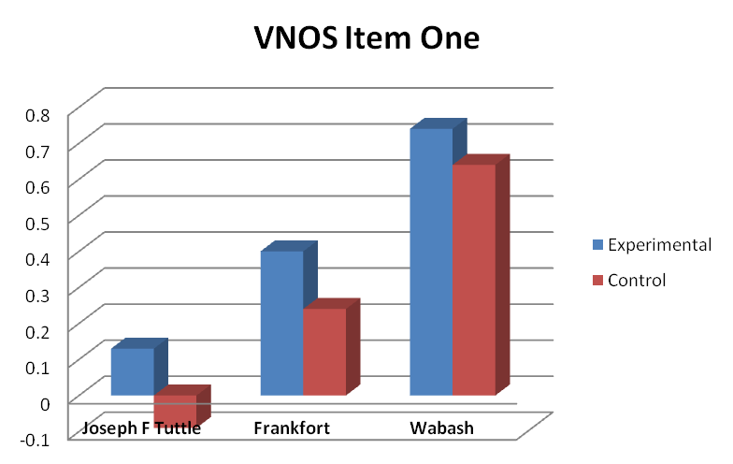
- Overall, the experimental group outperformed the control group consistently at Frankfort MS.

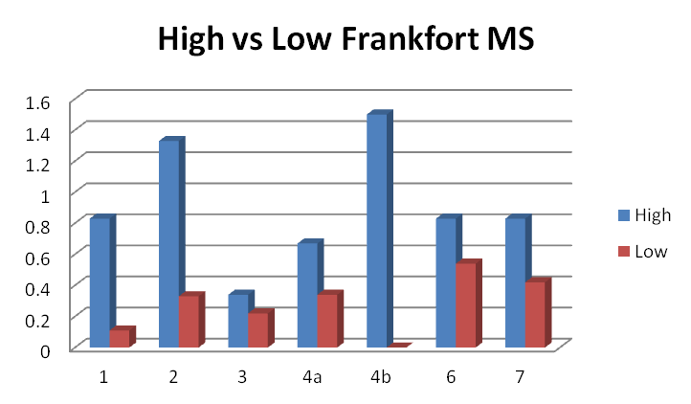
- The High Usage Group outperformed the Low Usage Group consistently across survey items (7/8 items) at Frankfort MS.

- Inferential Statistics Analysis for VNOS

D1. Experimental Group versus Control Group on VNOS Survey

Below are the statistical analyses conducted on the data and inferences gained. A Mann-Whitney Test was conducted on participants` total scores on pre VNOS questions; it revealed no significant difference between the experimental (Md = 11, n = 58) and control (Md = 11, n = 454) group, U = 12930, z = -.224, p = .823, r = .001. Likewise, aMann-Whitney test conducted on total scores on the post VNOS test indicated no significant differences between experimental (Md = 13, n = 58) and control (Md = 14, n = 454), U = 12.266, z = -.852, p = .394, r = .037 group. These results show that the performance of the experimental group and the control groups did not differ significantly from each other on both pre and post VNOS tests.

However, a Wilcoxon Signed Rank Test revealed a significant difference increase on the post VNOS test, z = -12.616, p < .001, with a medium effect size (r = .34) on the overall data. The median score on the VNOS test increased from pre-test (Md =11) to post-test (Md = 14). This suggests that irrespective of whether students watched the science videos, there was a significant score change from the pre-test to the post-test. Consequently, the data were split into two: experimental and control. A Wilcoxon Signed Rank Test conducted on the basis of the experimental group’s data showed a significant increase between pre-VNOS (Md = 11) and post-VNOS (Md = 13), z = -.3.431, p = .001, with a medium effect size (r = .31). In other words, the performance of the students who watched the videos increased significantly with a medium size change. All these raise whether high video watching group (number of videos watched > 5) in the experimental group and low video watching group (number of videos watched < 5) differed from each other in terms of actual VNOS gain scores. The Mann-Whitney test conducted in this regard indicated that those watching more than 5 videos did not achieve a significantly higher score (Md = 3, n = 33) than those who watched less than 5 videos (Md = 2, n = 25), U = 384, z = -.449, p = .653, r = .06. This result suggests that the number of videos watched did not impact the medium size significant performance increase between pre VNOS and post VNOS in the experimental group.

A corresponding Wilcoxon Signed Rank Test was also run on control groups` data as well. This test revealed that control group’s performance increased significantly between pre VNOS (Md = 11) and post VNOS (Md = 14), z = -12.201, with a medium effect size (r = .40). In addition to the results stated below, these also show that both performance of students who watched the educational videos and that of those who did not watch the videos showed a significant increase from pretest to post test. These results were also confirmed by a Mann-Whitney Test comparing overall performance of experimental and control groups on the basis of actual gain scores (posttest – pretest). Moreover, this test confirmed that both the experimental group (Md = 2.5, n =58) and control group (Md = 3, n = 454) achieved the same amount of actual gain scores from pre VNOS to post VNOS, U = 12.223, z = -.891, p = .373, r = .040. Graph 1 below presents the mean scores of experimental and control groups on pre VNOS and post VNOS tests:

Graph1. Mean Scores achieved by experimental and control groups on pre and post VNOS tests
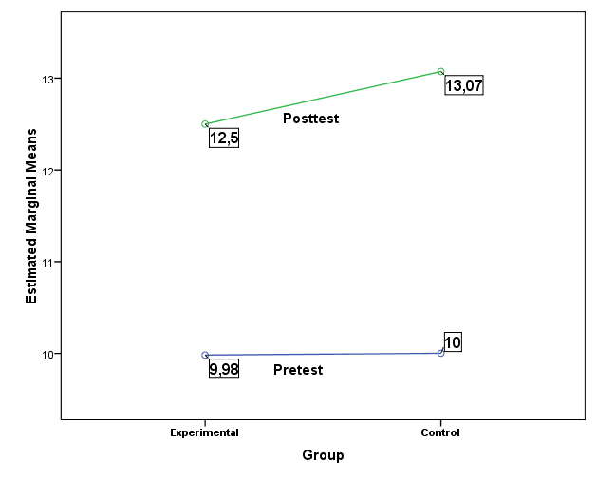

In order to gain further insights into the findings above, an item-by-item analysis was conducted in order to see whether experimental and control group achieved significantly different points from each other on each VNOS question. Accordingly, separate Wilcoxon Signed Rank Tests were run on pre and post versions of each VNOS question yielded that experimental and control groups performed better while answering post VNOS questions (p`s <.05). However, there were not significant performance differences all the time. Table 1 shows both experimental group and control group and the VNOS questions on which they got higher scores over time:

Table1. Experimental vs. Control Group: Posttest Performance on Individual VNOS Items

Group
Experimental | VNOS1 | VNOS2b  (p=.059) | VNOS3  (p=.079) | VNOS4a | VNOS4b | X | VNOS6 | X
Control | VNOS1 | VNOS2b | VNOS3 | VNOS4a | VNOS4b | VNOS5 | VNOS6 | VNOS7
Note: All p`s (except those for VNOS2b and VNOS3 of the experimental group) < .05

Table 1 shows that control group increased their performance on more questions on the post VNOS test. As for experimental group, they achieved marginally significant higher score on post VNOS2b (p = .059) while the performance increase on post VNOS3 demonstrates a potential trend (p = .079). However, it should be noted once more that performance differences of both experimental and control group between pre VNOS and post VNOS tests were significant and medium size.

A Kruskal-Wallis Test produced a statistically significant difference in actual gain scores earned between pre and post VNOS tests across the different teachers enrolled in the project (T1, n = 41; T2, n = 109; T3, n = 5; T4, n = 81; T5, n =19; T6, n = 86; T7, n = 89; T8, n = 48; T9, n = 34), χ² (8, n = 512) = 29.60, p < .001. Combined with the previous findings, this finding reveals that irrespective of their experimental group, students achieved significantly different scores on post VNOS test but this increased performance also changed significantly across teachers. This prompts whether the same differences hold true across experimental and control group. Consequently, separate Kruskal-Wallis Tests were also conducted for experimental and control group. The Test conducted for experimental group revealed a non-significant result (T1, n = 5; T2, n = 18; T3, n = 1; T6, n = 6; T7, n = 9; T8, n = 15; T9, n = 4), χ² (6, n = 58) = 4.60, p > .05. This suggests that in the experimental group VNOS performance of students did not change across teachers. However, Kruskal-Wallis test conducted in the control group showed a significant performance difference across teachers (T1, n = 36; T2, n = 2; T3, n = 4; T4, n = 81; T5, n = 19; T6, n = 80; T7, n = 80; T8, n = 33; T9, n = 30), χ² (8, n = 454) = 25.78, p = .001. This result indicates that the significant performance increase of the control group may have stemmed from teacher differences, possibly content covered or teaching styles/methods. However, this result should be read into very carefully since experimental and control groups were generally taught within the same classroom by the same teacher. Hence, considering that no teacher difference was found in the experimental group but in the control group may have also originated from possible student differences. For instance, one teacher’s students (referred to as T3) were entirely designated as special education students. These students achieved median actual gain scores below “0” regardless of whether they were in the experimental group (Md = -7) or control group (Md = -2).

A Kruskal-Wallis Test produced a statistically significant difference in actual gain scores earned between pre and post VNOS tests across different schools as well (S1, n = 155; S2, n = 100; S3, n = 175; S4, n = 82), χ² (3, n = 512) = 13.82, p = .003. This finding points out that students in some schools gained more actual gain scores on the post-VNOS test than others. In order to test whether these school differences hold true for experimental and control groups, Kruskal-Wallis Tests were conducted separately in experimental and control groups. The test run on experimental group’s data revealed no significant results (S1, n = 24; S3, n = 15; S4, n = 19), χ² (2, n = 58) = 2.41, p > .05. On the other hand, Kruskal-Wallis Test conducted in the control group showed a significant difference among the schools (S1, n = 131; S2, 100; S3, n = 160; S4, n = 63), χ² (3, n = 454) = 11.22, p = .011. This implies that actual gain scores of students in the control group changed significantly across schools. Consequently, some possible school differences may have also affected the control group’s increased performance on the post VNOS test. However, it should be noted that this result is in line with the result that control students` performance also changed significantly across teachers as well. Therefore, it is possible that significant differences across schools may relate to teacher differences or vice versa. In other words, it is possible that school and teacher effects may also interact in certain ways.

D2. Summary of Significant Findings

- The experimental group demonstrated a significantly higher score on the post VNOS test (Md = 13) compared to the pretest (Md = 11), which indicates that the educational videos may have played a part, along with school curriculum, to improve experimental group’s performance to a certain extent. The control group’s VNOS performance also increased from pretest (Md = 11) to posttest (Md = 14) significantly.
- The number of videos (high usage versus low usage group) did not lead to significant performance increases for the experimental group. In other words, the number of videos watched, whether it be 2 or 10 did not have an effect.
- Concerning each VNOS question, the control group achieved higher scores on more post VNOS questions than did the experimental group.
- For the control group, there was a significant difference among schools and teachers in terms of actual gain scores between pre and post VNOS tests. These possible differences may have also added to the significant performance increase of the control group on the VNOS test.
- Because the control group’s performance differed significantly across both schools and teachers, it is also possible that “schools” and “teachers” may also have a combined effect on control group’s performance.

Standards-Based CONTENT SURVEY

The standards-based content survey was developed for the Xfinity project by a 6th grade science teacher consultant. Shannon Hudson, our lead teacher consultant for the project, has received multiple science teaching awards and has over 20 years’ science teaching experience. The Content survey was designed to assess 6th grade students’ understanding of science within the larger framework of the 6th grade science standards for Indiana. The Content survey aligned with 6 state standards for science as follow:

- Standard 1: Nature of Science and Technology
- Standard 2: Scientific Thinking
- Standard 3: Physical Setting
- Standard 4: Living Environment
- Standard 5: Historical Perspectives and Common Themes
- Standard 6: Mathematical World

Each question in the Content survey was indirectly related to ISTEP as a result of being aligned with the state standards. Please refer to Appendix A for survey items.

- Overall Pretest and Posttest Scores by School

- We divided the experimental group into high and low usage groups to measure the effect of usage variable.
- Based on Xfinity usage data and student logs, if a student watched more than 5 videos, the student clarified as high usage group. In the other hand, if a student watched less than 5 videos, the student clarified as low usage group.

Joseph F Tuttle |  |  | Pre Content Survey |  |  | Post Content Survey |  |  | Mean Difference (Post-Pre)
 |  |  | N | Mean | SD | N | Mean | SD
Overall |  |  | 155 | 13.76 | 5.76 | 155 | 21.13 | 5.99 | 7.37*
Experimental Group |  |  | 24 | 14.04 | 6.40 | 24 | 23.13 | 6.31 | 9.09
 |  | High Usage | 16 | 14.44 | 7.43 | 16 | 23.13 | 7.54 | 8.69
 |  | Low Usage | 8 | 13.25 | 3.88 | 8 | 23.13 | 2.99 | 9.88
Control Group |  |  | 131 | 13.71 | 5.66 | 131 | 20.76 | 5.89 | 7.05

Northridge |  | Pre Content Survey |  |  | Post Content Survey |  |  | Mean Difference (Post-Pre)
 |  | N | Mean | SD | N | Mean | SD
Control Group |  | 100 | 16.97 | 5.52 | 100 | 21.54 | 6.21 | 4.57*

Frankfort |  |  | Pre Content Survey |  |  | Post Content Survey |  |  | Mean Difference (Post-Pre)
 |  |  | N | Mean | SD | N | Mean | SD
Overall |  |  | 175 | 16.82 | 5.58 | 175 | 19.47 | 6.99 | 2.65*
Experimental Group |  |  | 15 | 19.53 | 5.01 | 15 | 21.87 | 4.31 | 2.34
 |  | High Usage | 6 | 22.00 | 3.41 | 6 | 24.50 | 3.21 | 2.50
 |  | Low Usage | 9 | 17.89 | 5.39 | 9 | 20.11 | 4.17 | 2.22
Control Group |  |  | 160 | 16.57 | 5.57 | 160 | 19.24 | 7.16 | 2.67

Wabash |  |  | Pre Content Survey |  |  | Post Content Survey |  |  | Mean Difference (Post-Pre)
 |  |  | N | Mean | SD | N | Mean | SD
Overall |  |  | 82 | 15.33 | 5.36 | 82 | 19.80 | 5.57 | 4.47*
Experimental Group |  |  | 19 | 17.37 | 5.78 | 19 | 21.79 | 5.47 | 4.42
 |  | High Usage | 11 | 17.73 | 6.36 | 11 | 22.27 | 6.57 | 4.54
 |  | Low Usage | 8 | 16.88 | 5.28 | 8 | 21.13 | 3.80 | 4.25
Control Group |  |  | 63 | 14.71 | 5.12 | 63 | 19.21 | 5.50 | 4.50
*p`s < .05

- Overall Pretest and Posttest Scores by School and Standard
(Note: each standard includes multiple survey items.)

Joseph F Tuttle |  |  | Pre Content Survey |  |  | Post Content Survey |  |  | Mean Difference (Post-Pre)
 |  |  | N | Mean | SD | N | Mean | SD
Standard 1 | Overall |  | 155 | 6.01 | 2.80 | 155 | 8.17 | 2.31 | 2.16*
 | Experimental Group |  | 24 | 6.54 | 2.89 | 24 | 8.67 | 2.41 | 2.13
 |  | High Usage | 16 | 6.69 | 3.22 | 16 | 8.13 | 2.78 | 1.44
 |  | Low Usage | 8 | 6.25 | 2.25 | 8 | 9.75 | 0.71 | 3.50
 | Control Group |  | 131 | 5.92 | 2.79 | 131 | 8.08 | 2.29 | 2.16
Standard 2 | Overall |  | 155 | 0.63 | 0.70 | 155 | 1.41 | 0.59 | 0.78*
 | Experimental Group |  | 24 | 0.79 | 0.78 | 24 | 1.42 | 0.58 | 0.63
 |  | High Usage | 16 | 0.81 | 0.83 | 16 | 1.38 | 0.62 | 0.57
 |  | Low Usage | 8 | 0.75 | 0.71 | 8 | 1.50 | 0.54 | 0.75
 | Control Group |  | 131 | 0.60 | 0.69 | 131 | 1.40 | 0.59 | 0.80
Standard 3 | Overall |  | 155 | 4.01 | 2.29 | 155 | 6.00 | 2.12 | 1.99*
 | Experimental Group |  | 24 | 3.88 | 2.49 | 24 | 6.79 | 2.28 | 2.91
 |  | High Usage | 16 | 3.94 | 2.70 | 16 | 6.94 | 2.24 | 3.00
 |  | Low Usage | 8 | 3.75 | 2.19 | 8 | 6.50 | 2.51 | 2.75
 | Control Group |  | 131 | 4.04 | 2.27 | 131 | 5.85 | 2.07 | 1.81
Standard 4 | Overall |  | 155 | 1.08 | 1.31 | 155 | 1.78 | 1.88 | 0.70*
 | Experimental Group |  | 24 | 1.25 | 1.51 | 24 | 2.06 | 1.95 | 0.81
 |  | High Usage | 16 | 1.38 | 1.71 | 16 | 2.50 | 2.22 | 1.12
 |  | Low Usage | 8 | 1.00 | 1.07 | 8 | 1.19 | 0.75 | 0.19
 | Control Group |  | 131 | 1.05 | 1.28 | 131 | 1.73 | 1.87 | 0.68
Standard 5 | Overall |  | 155 | 1.35 | 1.39 | 155 | 2.70 | 1.48 | 1.35*
 | Experimental Group |  | 24 | 0.88 | 1.08 | 24 | 3.08 | 1.44 | 2.20
 |  | High Usage | 16 | 0.88 | 1.20 | 16 | 3.06 | 1.57 | 2.18
 |  | Low Usage | 8 | 0.88 | 0.84 | 8 | 3.13 | 1.25 | 2.25
 | Control Group |  | 131 | 1.44 | 1.43 | 131 | 2.63 | 1.48 | 1.19
Standard 6 | Overall |  | 155 | 0.68 | 0.48 | 155 | 1.03 | 0.48 | 0.35*
 | Experimental Group |  | 24 | 0.71 | 0.55 | 24 | 1.08 | 0.28 | 0.37
 |  | High Usage | 16 | 0.75 | 0.58 | 16 | 1.13 | 0.34 | 0.38
 |  | Low Usage | 8 | 0.63 | 0.52 | 8 | 1.00 | 0.00 | 0.37
 | Control Group |  | 131 | 0.67 | 0.47 | 131 | 1.02 | 0.50 | 0.35

Northridge |  | Pre Content Survey |  |  | Post Content Survey |  |  | Mean Difference (Post-Pre)
 |  | N | Mean | SD | N | Mean | SD
Standard 1 | Control Group | 100 | 6.50 | 2.59 | 100 | 7.99 | 2.12 | 1.49*
Standard 2 | Control Group | 100 | 1.10 | 0.66 | 100 | 1.47 | 0.56 | 0.37*
Standard 3 | Control Group | 100 | 5.43 | 2.32 | 100 | 5.60 | 2.34 | 0.17
Standard 4 | Control Group | 100 | 0.84 | 1.43 | 100 | 2.40 | 1.82 | 1.56*
Standard 5 | Control Group | 100 | 2.21 | 1.62 | 100 | 2.97 | 1.53 | 0.76*
Standard 6 | Control Group | 100 | 0.89 | 0.40 | 100 | 1.07 | 0.41 | 0.18*

Frankfort |  |  | Pre Content Survey |  |  | Post Content Survey |  |  | Mean Difference (Post-Pre)
 | Frankfort |  | N | Mean | SD | N | Mean | SD
Standard 1 | Overall |  | 174 | 7.04 | 2.01 | 171 | 7.59 | 2.40 | 0.55*
 | Experimental Group |  | 15 | 7.47 | 1.77 | 15 | 8.60 | 1.18 | 1.13
 |  | High Usage | 6 | 7.67 | 1.21 | 6 | 9.33 | 1.03 | 1.66
 |  | Low Usage | 9 | 7.33 | 2.12 | 9 | 8.11 | 1.05 | 0.78
 | Control Group |  | 159 | 7.00 | 2.03 | 156 | 7.49 | 2.47 | 0.49
Standard 2 | Overall |  | 175 | 0.98 | 0.54 | 173 | 1.22 | 0.56 | 0.24*
 | Experimental Group |  | 15 | 1.20 | 0.41 | 15 | 1.40 | 0.63 | 0.20
 |  | High Usage | 6 | 1.33 | 0.52 | 6 | 1.33 | 0.82 | 0.00
 |  | Low Usage | 9 | 1.11 | 0.33 | 9 | 1.44 | 0.53 | 0.33
 | Control Group |  | 160 | 0.96 | 0.54 | 158 | 1.20 | 0.55 | 0.24
Standard 3 | Overall |  | 175 | 4.71 | 2.28 | 173 | 5.24 | 2.34 | 0.53*
 | Experimental Group |  | 15 | 6.27 | 2.34 | 15 | 6.00 | 2.14 | -0.27
 |  | High Usage | 6 | 7.33 | 1.75 | 6 | 6.83 | 1.60 | -0.50
 |  | Low Usage | 9 | 5.56 | 2.51 | 9 | 5.44 | 2.35 | -0.12
 | Control Group |  | 160 | 4.57 | 2.23 | 158 | 5.17 | 2.36 | 0.60
Standard 4 | Overall |  | 175 | 1.00 | 1.40 | 172 | 2.12 | 1.81 | 1.12*
 | Experimental Group |  | 15 | 1.13 | 1.36 | 15 | 2.00 | 1.52 | 0.87
 |  | High Usage | 6 | 1.83 | 1.84 | 6 | 2.33 | 1.03 | 0.50
 |  | Low Usage | 9 | 0.67 | 0.71 | 9 | 1.78 | 1.80 | 1.11
 | Control Group |  | 160 | 0.99 | 1.41 | 157 | 2.13 | 1.83 | 1.14
Standard 5 | Overall |  | 175 | 2.29 | 1.40 | 171 | 2.51 | 1.45 | 0.22
 | Experimental Group |  | 15 | 2.60 | 1.18 | 15 | 2.60 | 1.12 | 0.00
 |  | High Usage | 6 | 2.83 | 1.47 | 6 | 3.33 | 0.82 | 0.50
 |  | Low Usage | 9 | 2.44 | 1.01 | 9 | 2.11 | 1.05 | -0.33
 | Control Group |  | 160 | 2.26 | 1.42 | 156 | 2.50 | 1.48 | 0.24
Standard 6 | Overall |  | 175 | 0.83 | 0.48 | 172 | 1.03 | 0.65 | 0.20*
 | Experimental Group |  | 15 | 0.87 | 0.35 | 15 | 1.20 | 0.41 | 0.33
 |  | High Usage | 6 | 1.00 | 0.00 | 6 | 1.33 | 0.52 | 0.33
 |  | Low Usage | 9 | 0.78 | 0.44 | 9 | 1.11 | 0.33 | 0.33
 | Control Group |  | 160 | 0.83 | 0.49 | 157 | 1.01 | 0.67 | 0.18

Wabash |  |  | Pre Content Survey |  |  | Post Content Survey |  |  | Mean Difference (Post-Pre)
 |  |  | N | Mean | SD | N | Mean | SD
Standard 1 | Overall |  | 81 | 6.44 | 2.68 | 81 | 7.54 | 2.26 | 1.10*
 | Experimental Group |  | 19 | 6.84 | 3.08 | 19 | 8.11 | 2.10 | 1.27
 |  | High Usage | 11 | 6.27 | 3.80 | 11 | 7.82 | 2.68 | 1.55
 |  | Low Usage | 8 | 7.63 | 1.60 | 8 | 8.50 | 0.93 | 0.87
 | Control Group |  | 62 | 6.32 | 2.57 | 62 | 7.37 | 2.29 | 1.05
Standard 2 | Overall |  | 82 | 1.22 | 0.57 | 82 | 1.44 | 0.65 | 0.22*
 | Experimental Group |  | 19 | 1.37 | 0.50 | 19 | 1.53 | 0.51 | 0.16
 |  | High Usage | 11 | 1.45 | 0.52 | 11 | 1.55 | 0.52 | 0.10
 |  | Low Usage | 8 | 1.25 | 0.46 | 8 | 1.50 | 0.54 | 0.25
 | Control Group |  | 63 | 1.17 | 0.58 | 63 | 1.41 | 0.69 | 0.24
Standard 3 | Overall |  | 82 | 4.07 | 2.12 | 80 | 5.70 | 1.87 | 1.63*
 | Experimental Group |  | 19 | 5.42 | 2.31 | 19 | 6.63 | 1.67 | 1.21
 |  | High Usage | 11 | 5.64 | 2.06 | 11 | 6.82 | 1.89 | 1.18
 |  | Low Usage | 8 | 5.13 | 2.75 | 8 | 6.38 | 1.41 | 1.25
 | Control Group |  | 63 | 3.67 | 1.89 | 61 | 5.41 | 1.84 | 1.74
Standard 4 | Overall |  | 82 | 0.49 | 0.74 | 82 | 1.29 | 1.44 | 0.80*
 | Experimental Group |  | 19 | 0.58 | 0.84 | 19 | 1.18 | 1.62 | 0.60
 |  | High Usage | 11 | 0.64 | 0.92 | 11 | 1.50 | 1.94 | 0.86
 |  | Low Usage | 8 | 0.50 | 0.76 | 8 | 0.75 | 1.00 | 0.25
 | Control Group |  | 63 | 0.46 | 0.71 | 63 | 1.33 | 1.40 | 0.87
Standard 5 | Overall |  | 82 | 2.27 | 1.74 | 82 | 2.82 | 1.47 | 0.55*
 | Experimental Group |  | 19 | 2.42 | 1.77 | 19 | 3.42 | 1.22 | 1.00
 |  | High Usage | 11 | 2.82 | 1.47 | 11 | 3.64 | 0.92 | 0.82
 |  | Low Usage | 8 | 1.88 | 2.10 | 8 | 3.13 | 1.55 | 1.25
 | Control Group |  | 63 | 2.22 | 1.75 | 63 | 2.63 | 1.50 | 0.41
Standard 6 | Overall |  | 81 | 0.81 | 0.39 | 82 | 0.87 | 0.34 | 0.06
 | Experimental Group |  | 19 | 0.78 | 0.43 | 19 | 0.84 | 0.38 | 0.06
 |  | High Usage | 11 | 0.91 | 0.30 | 11 | 0.91 | 0.30 | 0.00
 |  | Low Usage | 8 | 0.57 | 0.54 | 8 | 0.75 | 0.46 | 0.18
 | Control Group |  | 63 | 0.83 | 0.38 | 63 | 0.87 | 0.34 | 0.04
*p`s < .05

- Patterns Analysis for Content Survey

- The experimental group outperformed the control group at Tuttle MS.
- The High Usage Group outperformed the Low Usage Group at Frankfort MS and Wabash MS.
- Standard One: The Experimental group outperformed the control group on standard one at Frankfort MS and Wabash MS.
- Standard Four: The Experimental group did better than the control group on standard four at Tuttle MS and Frankfort MS. Additionally, the High Usage Group outperformed the Low Usage Group at Tuttle MS and Wabash MS.
- Standard Five: The Experimental group outperformed the control group for standard five at Tuttle MS and Wabash MS.
- Standard Six: The Experimental group outperformed the control group on Standard 6 across all three schools (Northridge MS is a control school).
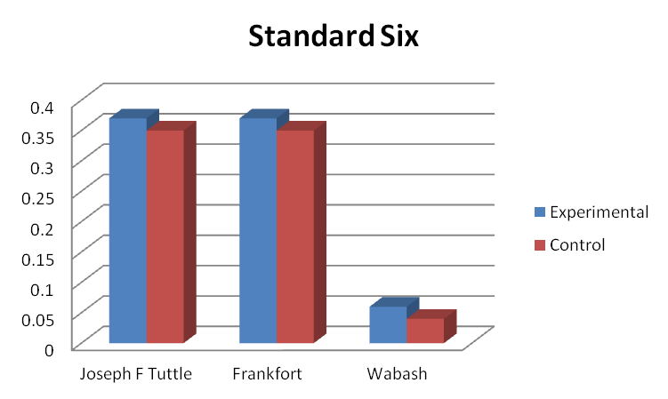

- Inferential Statistics for Content Survey

D1. Experimental Group versus Control Group on Content Survey

Separate Mann Whitney Tests were conducted on pre and post scores of each part of the content survey in order to see whether the experimental and control groups differed from each other significantly in terms of their performance level. These tests revealed that the experimental and control groups did not have significant score differences on the pretest for any of the 6 standards, suggesting that all participants began the study with the same level of knowledge on all standards (p`s > .05). Apart from standard 2, standard 4, and standard 6 questions, these tests revealed some significant differences between experimental and control groups on posttest scores.

There was not a significant performance difference between experimental (Md = 1, n = 58) and control group (Md = 1, n = 454), U = 11390, z = -1.88, p = .061 on pre standard 2 questions; however the p value shows a very strong trend, which means the experimental and control groups may not have been equal in terms of their knowledge on standard 2 at the beginning of the study. A similar non-significant result was also gained between experimental (Md = 1, n = 58) and control group (Md = 1, n = 452), U = 11993, z = -1.19, p = .23 on post standard 2 questions. The test conducted on pretest scores on standard 4 questions resulted in a non-significant difference between experimental (Md = .5, n = 58) and control group (Md = 0, n = 454), U = 12454, z = -.740, p = .46. Likewise there was not a significant performance difference between experimental (Md = 1, n = 58) and control group (Md = 1.5, n = 451) in terms of posttest scores on standard 4 questions, U = 12226, z = -.822, p = .41. Similar results were also detected on pretest and posttest questions on standard 6: There was not a significant difference between experimental (Md = 1, n = 57) and control group (Md = 1, n = 454) on pretest standard 6 questions, U = 12636, z = -.382, p = .70. No significant results in terms of posttest standard 6 questions between experimental (Md = 1, n = 58) and control group (Md = 1, n =451) were found either, U = 12533, z = -.742, p = .45. However, the following results were found regarding experimental versus control group difference on pretest and posttest questions for other standards:

- There was not a significant difference between experimental (Md = 7.5, n = 58) and control group (Md = 7, n = 452) in terms of pretest scores for standard 1 questions, U = 11511, z = -1.53, p = .13. On the other hand, a significant result between experimental (Md = 9, n = 58) and control group (Md = 8, n = 449) was gained on the posttest, U = 10464, z = -2.47, p = .013, with a small effect size (r = .10). These suggest that even though experimental group outperformed control group on posttest questions for the standard 1 questions significantly, the difference was a small one.

- Scores on pretest questions for standard 3 did not show significant difference between experimental (Md = 5, n = 58) and control group (Md = 4, n = 454), U = 11638, z = -1.45, p = .15. On the other hand, there was a significant performance difference between experimental (Md = 7, n = 58) and control group (Md = 6, n = 450) on the basis of the groups` scores on posttest questions for standard 3, U = 9622, z = -3.29, p = .001, with a small effect size (r = .15). These suggest that experimental group performed significantly better while the small effect size indicates that the significant performance difference was a small one.

- Between experimental (Md = 2, n = 58) and control group (Md = 2, n = 454), there was not a significant difference regarding pretest scores for standard 5 questions, U = 12282, z = -.85, p = .40. On the other hand, a significant score difference between experimental (Md = 3, n = 58) and control (Md = 3, n = 450) group on posttest questions was found for standard 5, U = 10951, z = -2.03, p = .042, with a small effect size (r = .09). Even though median scores for each group were the same in this case, the mean ranks were different (291 for experimental group and 250 for control group). This implies that the experimental group achieved a significantly better performance on standard 5 posttest questions compared to control group. However, the small effect size indicates that the performance difference was a small one.
Since possible significant performance differences were found across schools for VNOS scores, this was also checked for the content survey. Statistical analyses showed that there was not a significant difference across schools in terms of posttest scores for standards 1 and 5 (p`s > .05). However, there was a significant pretest score differences across schools for all standards (p`s < .05). Further analyses also showed that student scores have a tendency to change significantly across different teachers as well (all p `s < .05). As a result, the findings above should be read carefully due to the performance differences across schools and teachers.

D2. Summary of Significant Findings

- The experimental and control groups started the study at the same level of knowledge in terms of the content test.
- No effects of watching the educational videos could be detected on Standards 2, 3, or 6.
- Despite the small effect size of the difference, the experimental group outperformed the control group on post standard 1 questions.
- Despite the small effect size of the difference, the experimental group outperformed the control group on post standard 3 questions.
- Despite the small effect size of the difference, the experimental group outperformed the control group on post standard 5 questions.
- Students` performance scores showed some differences across schools and teachers, which should be kept in mind when interpreting the results.

PALS SURVEY RESULTS

The PALS (Patterns of Adaptive Learning Scales) Survey was provided to all participants as a pretest and posttest assessment. The PALS survey was developed and refined over time by a group of researchers using goal orientation theory to examine the relation between the learning environment and students’ motivation, affect, and behavior (Midgley et al., 2000). The PALS survey consists of multiple scales, five of which we utilized for this project. The five sections or scales included are:

- Mastery Goal: When oriented to mastery goals, students’ purpose or goal in an achievement setting is to develop their competence. They seek to extend their mastery and understanding. Attention is focused on the task. A mastery goal orientation has been associated with adaptive patterns of learning.
- Performance-Approach Goal: When oriented to performance-approach goals, students’ purpose or goal in an achievement setting is to demonstrate their competence. Attention is focused on the self. A performance-approach orientation has been associated with both adaptive and maladaptive patterns of learning.
- Performance-Avoid Goal: When oriented to performance-avoid goals, students’ purpose or goal in an achievement setting is to avoid the demonstration of incompetence. Attention is focused on the self. A performance-avoid orientation has been associated with maladaptive patterns of learning.
- Academic Efficacy: This refers to students’ perceptions of their competence to do their class work.
- Avoiding Novelty: This refers to students' preference for avoiding unfamiliar or new work. (Midgley et al., 2000).

The PALS survey uses five point Likert-type scale. Items on the student scales are anchored at 1 = "Not at all true,” 3 = "Somewhat true,” and 5 = "Very true." Please refer to Appendix A for survey items.

- Overall Pretest and Posttest Scores by School

- We divided the experimental group into high and low usage groups to measure the effect of usage variable.
- Based on Xfinity usage data and student logs, if a student watched more than 5 videos, the student clarified as high usage group. In the other hand, if a student watched less than 5 videos, the student clarified as low usage group.

Joseph F Tuttle |  |  | Pre PALS Survey |  |  | Post PALS Survey |  |  | Mean Difference (Post-Pre)
 |  |  | N | Mean | SD | N | Mean | SD
Overall |  |  | 142 | 87.80 | 11.48 | 142 | 87.35 | 12.15 | -0.45
Experimental Group |  |  | 21 | 86.62 | 11.63 | 21 | 87.43 | 9.75 | 0.81
 |  | High Usage | 14 | 90.14 | 11.80 | 13 | 87.08 | 8.83 | -3.06
 |  | Low Usage | 7 | 79.60 | 7.85 | 8 | 88.00 | 11.71 | 8.40
Control Group |  |  | 121 | 88.00 | 11.49 | 121 | 87.34 | 12.56 | -0.66

Northridge |  | Pre PALS Survey |  |  | Post PALS Survey |  |  | Mean Difference (Post-Pre)
 |  | N | Mean | SD | N | Mean | SD
Control Group |  | 89 | 83.12 | 14.36 | 93 | 80.56 | 15.07 | -2.56*

Frankfort |  |  | Pre PALS Survey |  |  | Post PALS Survey |  |  | Mean Difference (Post-Pre)
 |  |  | N | Mean | SD | N | Mean | SD
Overall |  |  | 134 | 88.06 | 11.29 | 153 | 86.41 | 11.56 | -1.65*
Experimental Group |  |  | 11 | 88.18 | 11.70 | 11 | 86.64 | 15.00 | -1.54
 |  | High Usage | 2 | 93.00 | 4.24 | 3 | 88.67 | 11.85 | -4.33
 |  | Low Usage | 9 | 87.11 | 12.72 | 8 | 85.88 | 16.70 | -1.23
Control Group |  |  | 123 | 88.05 | 11.30 | 142 | 86.40 | 11.32 | -1.65

Wabash |  |  | Pre PALS Survey |  |  | Post PALS Survey |  |  | Mean Difference (Post-Pre)
 |  |  | N | Mean | SD | N | Mean | SD
Overall |  |  | 74 | 85.31 | 13.03 | 72 | 81.79 | 14.74 | -3.52*
Experimental Group |  |  | 16 | 89.38 | 8.84 | 18 | 85.33 | 12.03 | -4.05
 |  | High Usage | 10 | 89.10 | 8.83 | 11 | 85.27 | 13.99 | -3.83
 |  | Low Usage | 6 | 89.83 | 9.68 | 7 | 85.43 | 9.16 | -4.40
Control Group |  |  | 58 | 84.19 | 13.81 | 54 | 80.61 | 15.46 | -3.58
*p`s < .05

- Overall Pretest and Posttest PALS Scores by School and Categories

Joseph F Tuttle |  |  | Pre PALS Survey |  |  | Post PALS Survey |  |  | Mean Difference (Post-Pre)
 |  |  | N | Mean | SD | N | Mean | SD
Mastery Goal | Overall |  | 148 | 4.37 | 0.57 | 155 | 4.41 | 0.68 | 0.04
 | Experimental Group |  | 21 | 4.37 | 0.51 | 24 | 4.52 | 0.53 | 0.15
 |  | High Usage | 14 | 4.40 | 0.61 | 16 | 4.60 | 0.50 | 0.20
 |  | Low Usage | 7 | 4.31 | 0.28 | 8 | 4.35 | 0.60 | 0.04
 | Control Group |  | 127 | 4.37 | 0.58 | 131 | 4.39 | 0.71 | 0.02
Performance Approaching Goal | Overall |  | 150 | 3.31 | 1.02 | 155 | 2.96 | 1.12 | -0.35*
 | Experimental Group |  | 22 | 3.17 | 1.08 | 24 | 2.90 | 1.03 | -0.27
 |  | High Usage | 14 | 3.33 | 1.15 | 16 | 2.74 | 1.05 | -0.59
 |  | Low Usage | 8 | 2.91 | 0.96 | 8 | 3.20 | 0.97 | 0.29
 | Control Group |  | 128 | 3.33 | 1.01 | 131 | 2.97 | 1.15 | -0.36
Performance Avoid Goal | Overall |  | 150 | 3.65 | 0.93 | 155 | 3.52 | 0.90 | -0.13
 | Experimental Group |  | 22 | 3.51 | 0.98 | 24 | 3.31 | 0.94 | -0.20
 |  | High Usage | 14 | 3.73 | 1.03 | 16 | 3.22 | 1.06 | -0.51
 |  | Low Usage | 8 | 3.13 | 0.82 | 8 | 3.50 | 0.70 | 0.37
 | Control Group |  | 128 | 3.67 | 0.92 | 131 | 3.56 | 0.90 | -0.11
Academic Efficacy | Overall |  | 150 | 3.99 | 0.75 | 153 | 4.11 | 0.76 | 0.12
 | Experimental Group |  | 22 | 4.06 | 0.69 | 24 | 4.24 | 0.67 | 0.18
 |  | High Usage | 14 | 4.30 | 0.68 | 16 | 4.31 | 0.64 | 0.01
 |  | Low Usage | 8 | 3.65 | 0.52 | 8 | 4.10 | 0.76 | 0.45
 | Control Group |  | 128 | 3.98 | 0.76 | 129 | 4.09 | 0.78 | 0.11
Avoiding Novelty | Overall |  | 146 | 2.98 | 0.96 | 145 | 3.15 | 1.05 | 0.17
 | Experimental Group |  | 22 | 2.92 | 0.93 | 22 | 3.35 | 1.01 | 0.43
 |  | High Usage | 14 | 3.01 | 0.93 | 14 | 3.46 | 1.14 | 0.45
 |  | Low Usage | 8 | 2.75 | 0.98 | 8 | 3.15 | 0.78 | 0.40
 | Control Group |  | 124 | 2.10 | 0.98 | 123 | 3.11 | 1.05 | 2.13

Northridge |  | Pre PALS Survey |  |  | Post PALS Survey |  |  | Mean Difference (Post-Pre)
 |  | N | Mean | SD | N | Mean | SD
Mastery Goal | Control Group | 96 | 4.01 | 0.84 | 97 | 3.96 | 0.86 | -0.05
Performance Approaching Goal | Control Group | 96 | 3.05 | 1.09 | 97 | 2.77 | 1.14 | -0.28*
Performance Avoid Goal | Control Group | 97 | 3.55 | 0.97 | 98 | 3.19 | 1.04 | -0.36*
Academic Efficacy | Control Group | 97 | 3.67 | 0.93 | 98 | 3.81 | 0.92 | 0.14
Avoiding Novelty | Control Group | 95 | 2.96 | 1.15 | 97 | 2.98 | 1.03 | 0.02

Frankfort |  |  | Pre PALS Survey |  |  | Post PALS Survey |  |  | Mean Difference (Post-Pre)
 |  |  | N | Mean | SD | N | Mean | SD
Mastery Goal | Overall |  | 151 | 4.40 | 0.54 | 161 | 4.33 | 0.65 | -0.07
 | Experimental Group |  | 11 | 4.42 | 0.53 | 12 | 4.18 | 0.67 | -0.24
 |  | High Usage | 2 | 4.60 | 0.00 | 4 | 4.35 | 0.44 | -025
 |  | Low Usage | 9 | 4.38 | 0.59 | 8 | 4.10 | 0.77 | -0.28
 | Control Group |  | 140 | 4.40 | 0.54 | 149 | 4.34 | 0.65 | -0.06
Performance Approaching Goal | Overall |  | 151 | 3.29 | 1.01 | 161 | 3.08 | 0.97 | -0.21*
 | Experimental Group |  | 11 | 3.02 | 1.25 | 12 | 2.98 | 1.13 | -0.04
 |  | High Usage | 2 | 3.60 | 1.98 | 4 | 3.50 | 0.50 | -0.10
 |  | Low Usage | 9 | 2.89 | 1.17 | 8 | 2.73 | 1.30 | -0.16
 | Control Group |  | 140 | 3.31 | 0.99 | 149 | 3.08 | 0.96 | -0.23
Performance Avoid Goal | Overall |  | 150 | 3.67 | 0.96 | 160 | 3.44 | 0.98 | -0.23
 | Experimental Group |  | 11 | 3.86 | 0.96 | 12 | 3.73 | 1.03 | -0.13
 |  | High Usage | 2 | 4.88 | 0.18 | 4 | 4.06 | 1.42 | -0.82
 |  | Low Usage | 9 | 3.64 | 0.92 | 8 | 3.56 | 0.83 | -0.08
 | Control Group |  | 139 | 3.65 | 0.96 | 148 | 3.41 | 0.98 | -0.24
Academic Efficacy | Overall |  | 147 | 3.94 | 0.71 | 159 | 4.02 | 0.80 | 0.08
 | Experimental Group |  | 11 | 3.95 | 0.65 | 11 | 4.03 | 0.87 | 0.08
 |  | High Usage | 2 | 4.00 | 0.28 | 3 | 4.40 | 0.35 | 0.40
 |  | Low Usage | 9 | 3.93 | 0.71 | 8 | 3.90 | 0.10 | -0.03
 | Control Group |  | 136 | 3.93 | 0.72 | 148 | 4.02 | 0.79 | 0.09
Avoiding Novelty | Overall |  | 144 | 3.06 | 1.01 | 157 | 3.06 | 1.11 | 0.00
 | Experimental Group |  | 11 | 3.16 | 1.16 | 11 | 3.35 | 1.10 | 0.19
 |  | High Usage | 2 | 2.50 | 0.71 | 3 | 2.66 | 0.42 | 0.16
 |  | Low Usage | 9 | 3.31 | 1.22 | 8 | 3.60 | 1.20 | 0.29
 | Control Group |  | 133 | 3.05 | 1.00 | 146 | 3.04 | 1.12 | -0.01

Wabash |  |  | Pre PALS Survey |  |  | Post PALS Survey |  |  | Mean Difference (Post-Pre)
 |  |  | N | Mean | SD | N | Mean | SD
Mastery Goal | Overall |  | 79 | 4.38 | 0.58 | 75 | 4.14 | 0.77 | -0.24*
 | Experimental Group |  | 17 | 4.60 | 0.44 | 18 | 4.40 | 0.65 | -0.20
 |  | High Usage | 10 | 4.68 | 0.41 | 11 | 4.60 | 0.56 | -0.08
 |  | Low Usage | 7 | 4.49 | 0.49 | 7 | 4.09 | 0.71 | -0.40
 | Control Group |  | 62 | 4.32 | 0.60 | 57 | 4.06 | 0.79 | -0.26
Performance Approaching Goal | Overall |  | 79 | 3.10 | 1.15 | 75 | 3.08 | 1.24 | -0.02
 | Experimental Group |  | 17 | 3.15 | 0.80 | 18 | 3.23 | 0.98 | 0.08
 |  | High Usage | 10 | 3.10 | 1.02 | 11 | 3.22 | 1.23 | 0.12
 |  | Low Usage | 7 | 3.23 | 0.39 | 7 | 3.26 | 0.44 | 0.03
 | Control Group |  | 62 | 3.08 | 1.24 | 57 | 3.04 | 1.32 | -0.04
Performance Avoid Goal | Overall |  | 80 | 3.70 | 0.90 | 74 | 3.37 | 1.19 | -0.33*
 | Experimental Group |  | 18 | 3.73 | 0.83 | 18 | 3.29 | 0.97 | -0.44
 |  | High Usage | 11 | 3.73 | 0.88 | 11 | 3.09 | 0.81 | -0.64
 |  | Low Usage | 7 | 3.75 | 0.80 | 7 | 3.61 | 1.18 | -0.14
 | Control Group |  | 62 | 3.69 | 0.93 | 56 | 3.40 | 1.26 | -0.29
Academic Efficacy | Overall |  | 80 | 3.91 | 0.87 | 73 | 3.75 | 0.89 | -0.16*
 | Experimental Group |  | 18 | 4.19 | 0.65 | 18 | 3.79 | 0.82 | -0.40
 |  | High Usage | 11 | 4.33 | 0.56 | 11 | 3.87 | 0.82 | -0.46
 |  | Low Usage | 7 | 3.97 | 0.77 | 7 | 3.66 | 0.87 | -0.31
 | Control Group |  | 62 | 3.83 | 0.91 | 55 | 3.74 | 0.91 | -0.09
Avoiding Novelty | Overall |  | 76 | 2.74 | 1.07 | 73 | 2.65 | 1.06 | -0.09
 | Experimental Group |  | 17 | 3.02 | 1.02 | 18 | 3.01 | 0.95 | -0.01
 |  | High Usage | 11 | 3.02 | 1.17 | 11 | 2.89 | 0.77 | -0.13
 |  | Low Usage | 6 | 3.03 | 0.76 | 7 | 3.20 | 1.22 | 0.17
 | Control Group |  | 59 | 2.66 | 1.08 | 55 | 2.53 | 1.07 | -0.13

- Patterns Analysis for PALS

- Overall the experimental group outperformed the control group at Tuttle MS and Frankfort MS.
- Overall the Low Usage Group outperformed the High Usage Group across all three experimental schools.
- Performance Approach Goal: The experimental group outperformed the control group across all three experimental schools consistently.
- Performance Approach Goal: The High Usage Group outperformed the Low Usage Group at MS and Wabash MS.

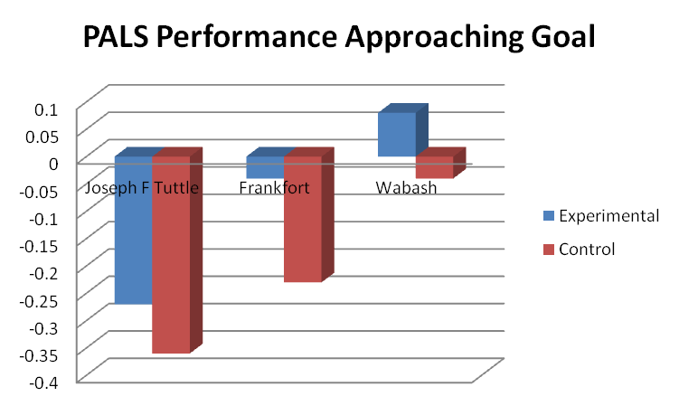

- Academic Efficacy: Control group did better than experimental group across all schools.
- Mastery Goal: Experimental group outperformed control group at Tuttle MS and Wabash MS. High Usage Group outperformed Low Usage Group across all three schools consistently.
- Avoiding Novelty: Experimental group did better than control group at Frankfort MS and Wabash MS.
- Performance Avoid Goal: Low Usage Group outperformed High Usage Group across all three schools.

- Inferential Statistics for PALS

D1. Experimental Group versus Control Group on PALS Survey

Mann Whitney Tests were conducted separately on pre and post ratings on each category for the PALS scale in order to determine whether experimental and control groups differed from each other significantly in terms of their overall ratings. These tests revealed that the experimental and control groups did not differ significantly from each other in terms of their overall ratings for each category of the PALS survey (p`s > .05). Accordingly, in order to check whether the groups may have differed from each other on the parts of the rating differences between pre and post administrations of the survey regarding each part, separate Wilcoxon Signed Rank Tests were conducted on the overall data. These tests produced non-significant differences between pre and post ratings on the following subpart of the PALS survey: mastery goal, academic efficacy, and avoiding novelty. On the other hand, significant differences were found between pre and post administrations of the following PALS parts: performance approach goal and performance avoid goal. Overall, all participants` ratings decreased significantly from pre to post administrations of these subparts regardless of whether they are in the experimental or control group (p`s = .000).

In order to check whether each group’s pre and post ratings changed significantly, Wilcoxon Signed Rank Tests were also conducted on each part of the PALS survey separately for experimental and control group. While the academic efficacy scale ratings did not differ significantly between the experimental and control groups, the control group’s ratings showed a strong trend towards significance, z = -1.81, p = .07, with a small effect size (r = .06). Even though median ratings of the control group on pre and post ratings for this part are the same (Md = 20), the mean ratings showed an increase from pretest (M = 19.16) to posttest (M = 19.60). Academic efficacy part of the PALS survey includes items about to what extent raters perceive themselves capable of dealing with the class work. Even though the effect size is small, the finding above suggests that control group’s perception of their ability to be successful in class work had a tendency to increase from pretest to posttest significantly. This would also explain the control group’s significant performance increases on some of the comprehension tests to some extent.

However, on the performance approach goal and the performance avoid goal categories of the PALS survey, the overall ratings for the experimental group were the same on pre and post ratings. The control group’s ratings showed a significant decrease from pretest to posttest on both parts. For the performance approach goal part, there was a significant reduction in control participants` ratings from pretest (Md = 16) to posttest (Md = 15), z = -4.75, p < .001, with a small effect size (r = .16). This indicates that control group’s perception of their orientation to demonstrating their competence has decreased from pretest to posttest even though this was a small reduction. Paying attention to showing competence has been related to both adaptive and maladaptive learning outcomes. Hence, since the control group performed as good as the experimental group, especially on VNOS test, it is reasonable to assume that control group participants` decreasing efforts to present their competence may have resulted in their performance increase. Similarly, the control group’s ratings on the performance avoid goal part of the PALS survey decreased significantly from pretest (Md = 15) to posttest (Md = 14) meaning that control group’s tendency to avoid demonstration of incompetence decreased significantly, z = -4.05, p < .001, with a small effect size (r = .14). This orientation to avoid showing incompetence has been associated with maladaptive learning patterns. Consequently, decrease of this orientation for the control group may also be another reason for the increased performance of the control group especially on VNOS test.

An across schools analysis showed that there was a significant difference among schools in terms of students` ratings on the PALS survey on both pre and post ratings on the mastery goal part (p`s < .05). This suggests that students` orientation to mastering learning goals showed differences among them during the project regardless of whether they were in the experimental or control groups. This may also have impacted students` performance during on both VNOS and standards test. Moreover, there was a significant difference across schools on post ratings for academic efficacy that is about students` perceptions of competence to do class work (p < .05) as well as a significant difference in terms of students` willingness to deal with new class work (p < .05).

Students` ratings on the PALS survey were also checked across teachers as well. Statistical analyses showed that groups of students of different teachers differed significantly from each other in terms of their ratings on pre and post ratings for both the mastery goal and the academic efficacy as well as post ratings for willingness to do unfamiliar class work (p`s < .05). However, no significant differences regarding performance approach goal (tendency to demonstrate competence) and performance avoid goal (orientation to avoiding the demonstration of incompetence) were found (p`s > .05). Added to other differences found across schools and teachers, these results also suggest that findings should be read while keeping possible school and teacher differences in mind. It should also be noted that parts of the PALS survey (mastery goal, academic efficacy, and willingness to do new class work) that differed significantly across schools and teachers are the same. This raises the possibility that “school” and “teacher” factors are most likely related or there may be a significant combined effect of the two.

D2. Summary of Significant Findings
- There were no significant differences between the experimental and control group in terms of their perceived ratings on pre and post administrations of each of the 5 categories of the PALS survey.
- For both the experimental and control groups there was a significant decrease from pre to post administrations of performance approach goal and performance avoid goal parts of the PALS survey for all students.
- The control group’s perception of competence to do class work (academic efficacy) showed a significant increase from pre (M = 19.16) to post (M = 19.60) test, while that of the experimental group remained the same.
- The control group’s tendency to show their competence in class (performance approach goal) decreased significantly between pre (Md = 16) and post (Md = 15) test, which would also partly explain the control group’s increased performance on some comprehension tests when associated with maladaptive learning. (Pre and post ratings of the experimental group did not differ significantly.)
- The control group’s orientation to avoid showing incompetence (performance avoid goal) decreased significantly from (Md = 15) to post (Md = 14) test, which would also explain the control group’s relatively good performance on tests since this orientation has been associated with maladaptive learning behaviors. (Pre and post ratings of the experimental group did not differ significantly.)
- Students` ratings on some parts of the PALS survey (i.e., academic efficacy, mastery goal, and willingness to do new class work) differed significantly across schools, which could have also impacted results.
- Students` ratings on academic efficacy, mastery goal and willingness to do new class work differed significantly across teachers, which could have also impacted the results.

OPEN-ENDED POST-TEST FOR EXPERIMENTAL PARTICPANTS

The Student Open-ended Question Posttest, which was only provided to students in the experimental group, was designed by the researchers to elicit details about students’ perceptions of the Xfinity on Demand Videos and potential links to their learning. A total of 99 students participated in this posttest, the “n” differs from other measures as it included students that may have later been removed during the data cleaning process for lack of other pre/posttest measures.

Graphs and Summary Tables for Survey Items
Q1. How many of the science videos do you think you watched this past year?
 | Frequency | Valid Percent
No video | 10 | 12.7
1-5 videos | 22 | 27.8
5-10 videos | 21 | 26.6
11 or more videos | 26 | 32.9
Total | 79 | 100.0

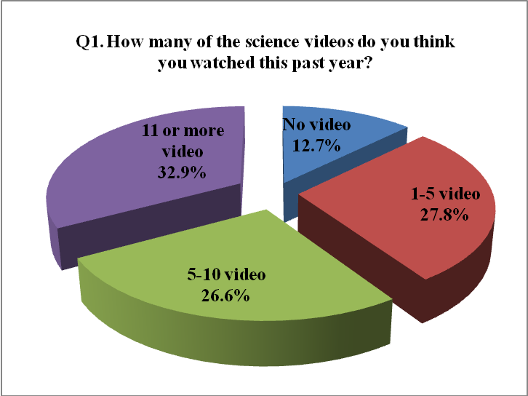

Findings

- 80% of students in experimental group responded (79 students out of 99 total students).
- 32.9% of students in experimental group watched 11 or more videos.
Q2. Where did you watch the Xfinity science videos? Select all that apply.
 | Frequency | Valid Percent
Your house | 64 | 75.3
Grand parents’ house | 6 | 7.1
Friend's house | 3 | 3.5
Library | 1 | 1.2
Somewhere Else | 11 | 12.9
Total | 85 | 100.0

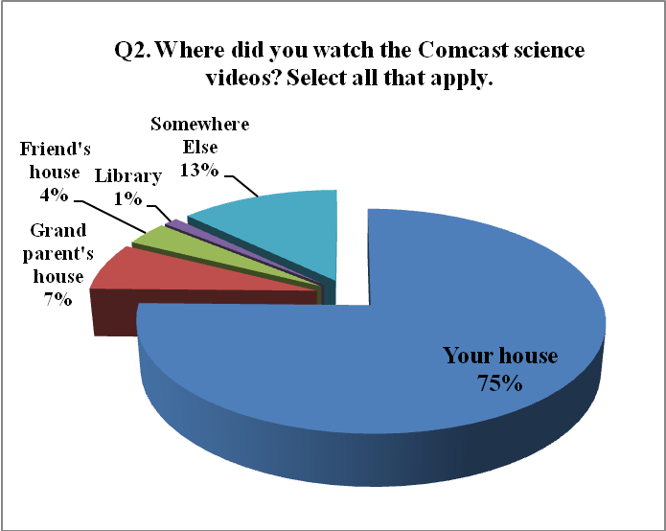

Findings

- 75.3% of students in experimental group watched the videos at their home.
- 14% of students in experimental group watched the videos at more than 2 places.

Q3. If you had to describe the Xfinity science videos to a friend, what would you tell them? Would you tell them the videos were helpful, easy to follow, fun, encouraged you to want to know more about science? What else?
Words used to describe the Xfinity science video |  | Frequency
Positive | Helpful | 28
 | Fun | 15
 | Interest | 11
 | Easy to understand/follow | 9
 | Cool/good | 6
 | Educational | 4
Negative | Boring/wasting time | 14
 | Need to be updated | 2

Findings

- More than 80% of students in experimental group had positive feedback related to the Xfinity science videos by using “Helpful”, “Fun”, “Interest”, “Easy to understand/follow”, “Cool/good”, and “Educational” to describe them.
- 35.44% of students in experimental group describe the Xfinity science videos as “Helpful”.

- 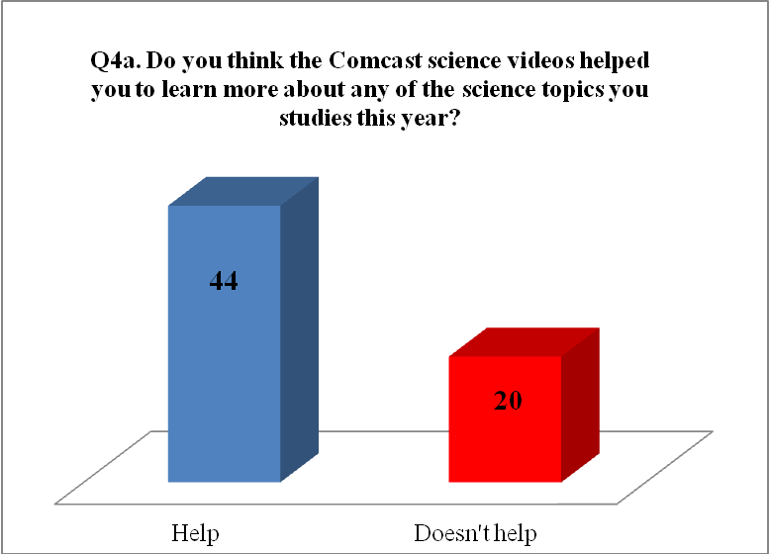

Q4b. Can you tell us which topics the videos helped you learn better?
Topic | Frequency
Plants | 1
Animal | 4
Space & planets | 15
Hurricanes | 1
Earth | 4
Volcano | 2
Cell | 3
Body | 2
Ocean | 5

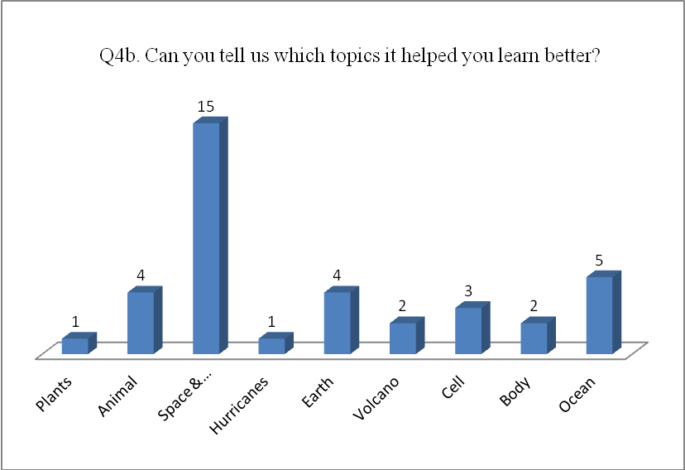

Findings

- “Space and planets” was verified as the most helpful topic among the Xfinity science videos.

Q5.Tell us what you thought about your ISTEP science test.
 | Frequency | Valid Percent
Easy | 48 | 62.3
Hard | 5 | 6.5
Not sure | 24 | 31.2
Total | 77 | 100.0

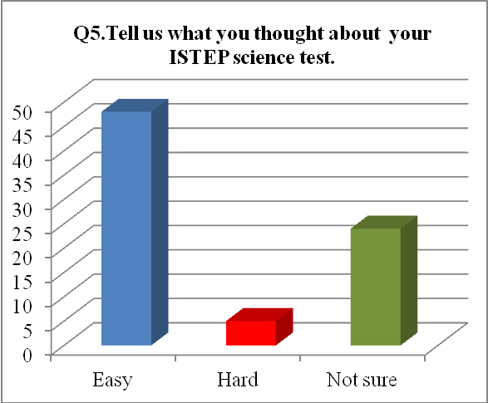

Findings

- 62.3% of students in experimental group thought that ISTEP science test was easy.

Q6. Do you think the Xfinity science videos helped you to do better on your ISTEP science test?
 | Frequency | Valid Percent
Yes | 47 | 63.5
No | 27 | 36.5
Total | 74 | 100.0

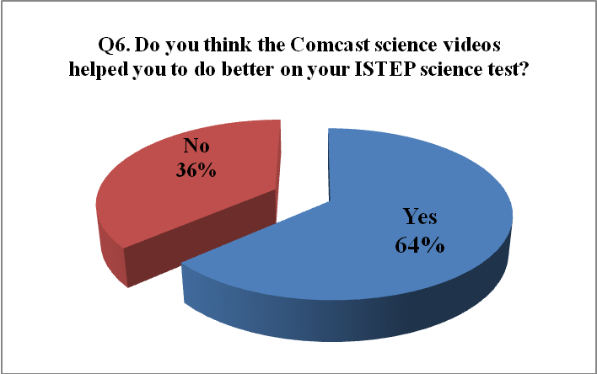

Findings

- 63.5% of students in experimental group thought that the Xfinity science videos helped them to do better on their ISTEP science test.

Q7. If you think the Xfinity science videos helped to learn better or do better in science, would you like a similar program for other subjects? Please tell us about it.
Language arts | 6
Social studies | 10
Math | 9
All subjects | 2
English | 1
History | 5

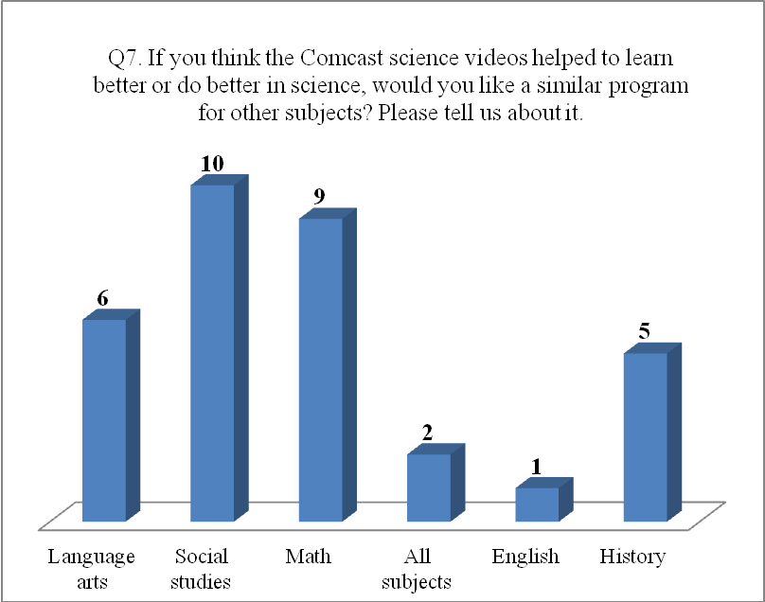

Findings

- “Social studies” and “Math” was selected as a similar program that students want to watch for their study on VOD from Xfinity.

STUDENT LOGS OPEN-ENEDED RESPONSES

The following section contains sample comments students provided for the videos they watched. This information was provided on the students’ video logs which was one method of determining the topic and number of videos watched by participants.

Video Title | Sample Comments
Earthquake-Proof | This video is about how to earthquake proof a house. The best part of the video was the simulation. It didn't really help me in school.
 | Smash lab tried ways to make a house earthquake proof by putting metal bulls under the house. When one house fell down. Yes, I did learn about earthquakes last semester.
 | Smash lab try's to protect a model from a earthquake. To watch test quake. It didn't help.
 | They tested ball baring and truck shocks to see which held up the best in an earthquake. The best part was when the truck shocks failed and the house fell apart. We haven't learned this yet.
 | This video finds out if ball bearings can make a house earthquake proof by creating a friction less surface. My favorite part was when they simulated an earthquake.
 | Smash lab made a earthquake proof house one with spins and another with meta balls. When the first house was destroyed. I did learn about earthquakes but last semester.
Atlas: Australia | This video is about Australia’s deep culture and Australia today. The best part was the deep culture inspired people. I didn't really help me in school.
 | The food does not need farming. Watching over Australia. No, it didn't help.
 | It talked about Australia's culture and its traditions and natures, and sports. When they talked about soccer. No we are not learning about Australia.
River Biomes | It's all about rivers and their biomes. Looking at a lot of rivers. It has not helped yet.
 | This video is about what river biome truly are. The best part was the different types of river biome. It helped me learn about oceans sort of.
Grassland Biomes | The video is about the different species grasses and types of grass and biomes. The best part was about the animals. It helped me learn about animals.
 | It talks about forests, wetlands, grassland, the types of grass in places, different kinds of grasses, prairies, deserts, forbs, photosynthesis, the human impact, the buffalo. The best part was about sods, and we haven't learned this yet.
 | Talks about 3 grass lands in North America. I didn't have a best part. No, I have not learned about grasslands.

Video Title | Sample Comments
Scientific Method | It talked about the steps of an experiment. I didn't have a best part. No, my class isn't learning about the scientific method.
 | The video is about how to form hypothesis, and how the steps of a hypothesis work. The best part was when the boy did the test with the toast. It was kind of helpful and we learned about this.
Bill Nye: Astronomy | The video is about stars, planets, moons, and the history of astronomy. The best part of is was learning about the stars. It helped me with astronomy science.
 | This video showed me some of the greatest discoveries. From the first telescope used in astronomy to the orbits of planets like mercury. The best part in this video was for me the picture. This video does in fact help kids of this age earn more about space.
 | This video is about astronomy which is the history of the sky for this video, the best part of the video was about the ancient people and what they had to do with the sky. It helped me learn about the planets.
 | It was about how planets and starts circle the earth, and who discovered this. The best part was about Einstein. We haven't learned this yet.
 | It talked about our solar system and the big bang theory. When they talked about the big bang theory. Yes, because we had learned about the solar system.
Bill Nye: Earth Sci | Talked about Earth inner and outer cores. When they talked about global warming and what happens to Earth. Yes, we had learned about Earth inner and outer cores.
What's Out There? | Talked about the other planets in the solar system. I didn't have a favorite part. Yes, because we had just learned about the planets.
The Solar System | Talked about the planets and stars. When it said that Mars used to constraint life. We had learned about the planets.
 | This is about the universe, planets. Planets rotation, planets size, moons, etc. The best part was about the forming of the Earth. It helped me learn about the planets.
 | This video is about planets, and what's on them, and their shape and form. The best part was about mars and its color. We haven't studied this yet
Plants_Life Cycle | It was about plants and the reproduction and the stages it goes through in life. The best part was about how the seeds get spread. We have learned this, but it helped me understand better.
Atomic Structure | It was about protons, neutrons, radioactivity, atoms, fusion, and the best part was about radioactivity. We haven't learned this yet.
Human Body Systems | It's about our skin, muscles, skeletal system, cartilage, blood cells, kidneys, heart, oxygen, respiratory system, stomach, intestines. The best part was about the respiratory system. This helped me and we're learned this.

Video Title | Sample Comments
Plants_Environ. Enclaves | It's about a biotic factors, biotic factors, population, leaves color, light and temperature to plants, water in plant tissue, symbiosis, food chain. The best part was about when the pot falls over and the plant changes direction and we have learned this and it helped me.
Desert Biomes | 5% of people live there. That dessert gets 10 inches of rain or snow a year. It hasn't helped.
 | It talks about some desert temperature desert landscapes, floods, ghost rain, wind erosion, weathering, life in desert, cacti, stored energy, the human impact. The best part was about the animals living in a cactus, and we haven't learned this yet.
Our Changing Earth | This video talks about weathering and erosion. The best part of the video was when it was talking about the different types of erosion. Yes, it does help with what I am learning in school.
 | This video shows me that the Earth is always changing. In this video, they use models. One model was having two table cloths laid flat on a table. Then you move the together to see how mountains might had formed. See picture #1. This video was helpful for learning. This topic because this video used historical events to emphasize the meaning of a ever changing Earth. Looking at Mt. St. Helen shows me that the Earth is always changing because of erosion or weathering. The Earth is changing.
 | This is about the changing, landforms, shifting of the continent and growing things on Earth. The best part is about the volcanoes on Earth years ago. It helped me understand reading about the formation of Earth.
 | Tells about the earth and its surface when the Earth was formed. No, this video wasn't about anything I learned.
Earth: Water Planet | This video talks about the oceans and water. The best part was when it talked about the different ecosystems of the ocean. No it did not help me that much in school.
 | This is mostly about all of the oceans and water formations on Earth. The best part of the video was talking about the marine life. It helped me understand how important and what a big part oceans are.
 | Under the ocean there are mountains that if they get high they create islands. There are many different kinds of currents. Ocean currents have an effect on climate. Water is the only thing that can be in all three states. (Gas, solid, liquid). The best part is al the clips of animals and forests. This video helped me learn how water is used in life and how much water we have on our planet Earth.
Ocean: Vastness | The Earth is 70% water. Looking inside the oceans. It hasn't helped yet.
 | It was about coast line, tides, tidal waves, oceans, and trances. The best part was about the water from earth being pulled by gravity when the moon, earch, and sun line up together. We haven't learned this yet.

Video Title | Sample Comments
Earth's Atmosphere | It talks about the atmosphere, weather, and climate. The best part was how the auroras form. It was helpful because my class is studying the atmosphere.
 | It's about the parts of atmosphere, ozone, stratosphere, exosphere, the sun, seasons, wind pressure, temper zones, wisterias, air, climate zones,, hurricanes, tornados, fossil fuel, pollution, smog. The best part was about the levels of the atmosphere ad we haven't learned this.
 | This video talks about the different types of the atmosphere. The best part was when it talks about the seasons. No, it did not really help me.
Hurricane-Proof | Smash lab tried to make a house hurricane proof using carbon. The best part was when the second house was demolished from inside. Yes, in science we are learning about winds and hurricanes.
 | They try to protect a house from a hurricane. The test when they stood on the boards. It did not help.
 | The video found out if carbon fiber can protect a house against a hurricane. My favorite part was when they were trying out different fans. No it didn't help me.
Big Bang | Scientist talks about the big bang theory. My favorite part was when the video showed the big bang. No, it didn't show anything I learned.
Runaway Trailer | Smash lab put rockets on trailer to stop them if the black fail. The best part was when the rockets blew up and made a huge cloud of smock. No, I haven't learned anything in class about rockets.
The cell | It talks about life. Looking at a cell. It might help.
High Rise Escape | This video is about using magnets to save people from a fire in a high rise. The goal is to get people down faster in a high rise in a fire without taking so much time going down stairs. The best part in this video is when they (smash lab) make small models. This video will help kids my age to learn the way magnets work. I have learned from this video.
Train Crash | This video is about how to keep the driver of a car safe when getting hit by a train. So the smash lab is trying to put an airbag on a train to make a train and car crash less dangerous. The best part in this video is when they dropped a car on a moon bounce. This video could teach others like me how air works.

References

Midgley, C., Maehr, M. L., Hruda, L. Z., Anderman, E., Anderman, L., Freeman, K. E., Gheen, M., Kaplan, A., Kumar, R., Middleton, M. J., Nelson, J., Roeser, R., & Urdan, T. (2000). Manual for the Patterns of Adaptive Learning Scales (PALS), Ann Arbor, MI: University of Michigan

Norm G. L., Fouad A., Randy L. B., & Rene´e S. S. (2002). Views of Nature of Science Questionnaire: Toward Valid and Meaningful Assessment of Learners’ Conceptions of Nature of Science. Journal of Research in Science Teaching. 39(6), 497–521.

Pallant, J. (2007). Survival manual: A step by step guide to data analysis using SPSS for windows (3rd edition). England: Open University Press.

Appendix A
Pre/Post Cover Letter and Surveys

Pre/Post Survey Cover Letter

Name ____________________________________________________

Science Teacher’s Name _____________________________________

School ___________________________________________________

--------------------------------------------------------------------------------------

Dear Student,

Attached are survey questions, some ask for your opinion while some ask for you to work out science problems. Some of the science questions will be about topics you have already learned about in your science class but others are about topics you may not cover until later in the school year. We do not expect you be able to answer all of them correctly this early in the school year. You will be asked to answer the same question at the end of the year—and we expect you will know a lot more of the answers at that time. You will not be graded on your answers, we just want to know what you think and know about these science topics right now. Your responses to these questions will not impact your grades in science class.

Sincerely,
Dr. Jennifer Richardson
Purdue University
Pre/Post Content Survey

Part 1. Sixth Grade Science Topics

Standard 1 Nature of Science and Technology
- If you were a scientist, what are five tools you would want to make sure you had?

- Look at the experiment below.
John and Joe want to set up an experiment to decide which bait is the best to catch catfish. They will be using the lake behind their house and the same type of fishing reel. They will go out to the lake at exactly 5 pm to do their experiment. They will fish for exactly 20 minutes using minnows, worms, fake plastic bait and maggots.

List two things that are good about their experiment
- _______________________________________________________________
- _______________________________________________________________

List two things that are not good about their experiment
- _______________________________________________________________
- _______________________________________________________________

- Scientists work a long time to come up with answers to why things happen. Sometimes they are wrong. Is their information still valuable? Why or why not?

Standard 2 Scientific Thinking

- The theory that the earth revolves around the sun has been taught for hundreds of years. Why do you think this theory is still accepted?

- Why is it necessary for scientists to read the research of other scientists?

Standard 3 Physical Setting

- Explain how the carbon dioxide and oxygen cycle works.

- Explain how the phases change as ice goes from ice to water to water vapor.

- Why is it hot in the summer in Indiana?

- Why does Earth need the sun?

- Why aren’t the stars always in the same place at night?

- What causes earthquakes?

- Why don’t rivers and lakes soak into the ground?

- How can oceans make electricity?

Standard 4 Living Environment

- Over time, elephant trunks have grown longer. Design an experiment and research project that would help explain why this happened.

- You have had a flower garden in your yard for 10 years. This year, everything died. Design an experiment to figure out why.

- Humans need bacteria. List 5 ways bacteria help humans.

- Why does rotten food smell?

Standard 6 Historical Perspectives and Common Themes

  - How has the theory of the structure of the atom changed over time? (Rutherford)

  - Why do things go down when I drop them? (Newton)

  - How is new sea floor made? (Wegner, Hess)

Standard 5 Mathematical World

- F= (1.8 x C) + 32. Convert 36 Celsius (select the closest number)
  - 122
  - 97
  - 52
  - 38

- Study the following chart.

Day | Temperature
Monday | 18
Tuesday | 20
Wednesday | 25
Thursday | 24
Friday | 23
Saturday | 10
Sunday | 8

  - What was the average temperature over the 7 days?

  - What do you think happened between Friday and Saturday to make the temperature drop so much?

  - Graph the temperatures below (or on the back of this sheet if you need more space).

Pre/Post VNOS Survey

Part 2. Your Views of Science and Scientists
Views of Nature of Science (VNOS-E)

Instructions

- Please answer each of the following questions. You can use all the space provided and the backs of the pages to answer a question.
- Some questions have more than one part. Please make sure you answer for each part.
- This is not a test and will not be graded. There are no “right” or “wrong” answers to the following questions. I am only interested in your ideas about the following questions.
- If you want you can draw pictures to help explain your ideas.

- What is science?

- (a) What are some of the other subjects/topics you are learning in your other classes

(b) How is science different from these other subjects?

- Scientists are always trying to learn more about our world. Do you think what scientists know today will change in the future?

- (a) How do scientists know that dinosaurs once lived on the earth?

(b) How sure are scientists about the way dinosaurs looked? Why?

- A long time ago all the dinosaurs died. Scientists have different ideas about why and how they died. If scientists all have the same facts about dinosaurs, then why do you think they disagree about this?

- TV weather people show pictures of how they think the weather will be for the next day. They use lots of scientific facts to help them make these pictures.
How sure do you think the weather people are about these pictures? Why?

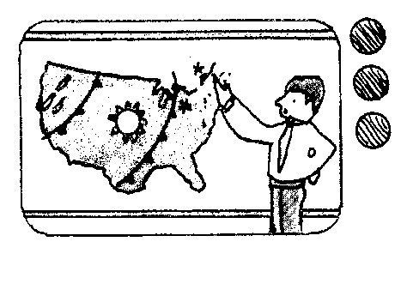

- (a) Do you think scientists use their imaginations when they do their work?
Yes No

(b) If No, explain why?

(c) If Yes, then when do you think they use their imaginations in their work?
Pre/Post PALS Survey

Part 3. Here are some questions about you as a student in this science class. Please circle the number that best describes what you think.

1. It’s important to me that I learn a lot of new concepts this year.
1 2 3 4 5
NOT AT ALL TRUE SOMEWHAT TRUE VERY TRUE

2. One of my goals in class is to learn as much as I can.
1 2 3 4 5
NOT AT ALL TRUE SOMEWHAT TRUE VERY TRUE

3. One of my goals is to master a lot of new skills this year.
1 2 3 4 5
NOT AT ALL TRUE SOMEWHAT TRUE VERY TRUE

4. It’s important to me that I thoroughly understand my class work.
1 2 3 4 5
NOT AT ALL TRUE SOMEWHAT TRUE VERY TRUE

5. It’s important to me that I improve my skills this year.
1 2 3 4 5
NOT AT ALL TRUE SOMEWHAT TRUE VERY TRUE

6. It’s important to me that other students in my class think I am good at my class work.
1 2 3 4 5
NOT AT ALL TRUE SOMEWHAT TRUE VERY TRUE

7. One of my goals is to show others that I’m good at my class work.
1 2 3 4 5
NOT AT ALL TRUE SOMEWHAT TRUE VERY TRUE

8. One of my goals is to show others that class work is easy for me.
1 2 3 4 5
NOT AT ALL TRUE SOMEWHAT TRUE VERY TRUE

9. One of my goals is to look smart in comparison to the other students in my class.
1 2 3 4 5
NOT AT ALL TRUE SOMEWHAT TRUE VERY TRUE

10. It’s important to me that I look smart compared to others in my class.
1 2 3 4 5
NOT AT ALL TRUE SOMEWHAT TRUE VERY TRUE

11. It’s important to me that I don’t look stupid in class.
1 2 3 4 5
NOT AT ALL TRUE SOMEWHAT TRUE VERY TRUE

12. One of my goals is to keep others from thinking I’m not smart in class.
1 2 3 4 5
NOT AT ALL TRUE SOMEWHAT TRUE VERY TRUE

13. It’s important to me that my teacher doesn’t think that I know less than others in class.
1 2 3 4 5
NOT AT ALL TRUE SOMEWHAT TRUE VERY TRUE

14. One of my goals in class is to avoid looking like I have trouble doing the work.
1 2 3 4 5
NOT AT ALL TRUE SOMEWHAT TRUE VERY TRUE

15. I'm certain I can master the skills taught in class this year.
1 2 3 4 5
NOT AT ALL TRUE SOMEWHAT TRUE VERY TRUE

16. I'm certain I can figure out how to do the most difficult class work.
1 2 3 4 5
NOT AT ALL TRUE SOMEWHAT TRUE VERY TRUE

17. I can do almost all the work in class if I don't give up.
1 2 3 4 5
NOT AT ALL TRUE SOMEWHAT TRUE VERY TRUE

18. Even if the work is hard, I can learn it.
1 2 3 4 5
NOT AT ALL TRUE SOMEWHAT TRUE VERY TRUE

19. I can do even the hardest work in this class if I try.
1 2 3 4 5
NOT AT ALL TRUE SOMEWHAT TRUE VERY TRUE

20. I would prefer to do class work that is familiar to me, rather than work I would have to learn
how to do
1 2 3 4 5
NOT AT ALL TRUE SOMEWHAT TRUE VERY TRUE

21. I don’t like to learn a lot of new concepts in class.
1 2 3 4 5
NOT AT ALL TRUE SOMEWHAT TRUE VERY TRUE

22. I prefer to do work as I have always done it, rather than trying something new.
1 2 3 4 5
NOT AT ALL TRUE SOMEWHAT TRUE VERY TRUE

23. I like academic concepts that are familiar to me, rather than those I haven’t thought about
before.
1 2 3 4 5
NOT AT ALL TRUE SOMEWHAT TRUE VERY TRUE

24. I would choose class work I knew I could do, rather than work I haven’t done before.
1 2 3 4 5
NOT AT ALL TRUE SOMEWHAT TRUE VERY TRUE

Appendix B
Open-ended Question Posttest for Experimental Students

Posttest for Experimental Students

Name _______________________________________________________
Science Teacher’s Name _________________________________________
School ________________________________________________________

If you participated in the Purdue/Xfinity educational science video program please complete these questions:
How many of the science videos do you think you watched this past year?
____0
____1-5
____5-10
____11 or more

Where did you watch the Xfinity science videos? Select all that apply.
____ Your house
____ Grand parent's house
____ Friend's house
____ Library
____ Somewhere Else

If you had to describe the Xfinity science videos to a friend, what would you tell them? Would you tell them the videos were helpful, easy to follow, fun, encouraged you to want to know more about science? What else? __________________________________________________________________________________________________________________________________________________________________________________________________________________________________________

Do you think the Xfinity science videos helped you to learn more about any of the science topics you studies this year? Can you tell us which topics it helped you learn better? __________________________________________________________________________________________________________________________________________________________________________________________________________________________________________

Tell us what you thought about your ISTEP science test.
They were _____easy ____ hard ____not sure

Do you think the Xfinity science videos helped you to do better on your ISTEP science test?
___yes ___ no

If you think the Xfinity science videos helped to learn better or do better in science, would you like a similar program for other subjects? Please tell us about it.
____________________________________________________________________________________________________________________________________________________________

Appendix C

Individual School Data and Comparison Data for Participating Schools
Data retrieved from the Indiana Department of Education websites: http://mustang.doe.state.in.us and http://compass.doe.in.gov

          - Individual School Data

Joseph F Tuttle Middle School, Crawfordsville Community School District

Median income: $40,867 in 2008 (State: $42,743)

School Enrollment 2009-10: 502
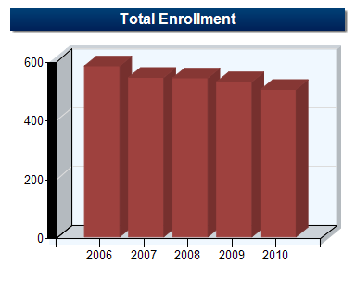
 | 2006 | 2007 | 2008 | 2009 | 2010
Grade 6 | 192 | 179 | 185 | 169 | 162
Grade 7 | 195 | 185 | 172 | 185 | 177
Grade 8 | 195 | 179 | 184 | 174 | 163
Total | 582 | 543 | 541 | 528 | 502

Ethnicity 2009-2010
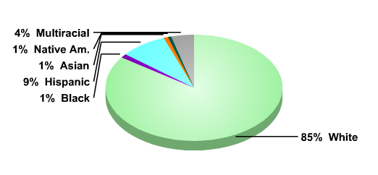
 | Students
American Indian | 2
Black | 6
Asian or Pacific Islander | 5
Hispanic | 43
White | 425
Multiracial | 21
Free/Reduced Lunch Information 2009-10
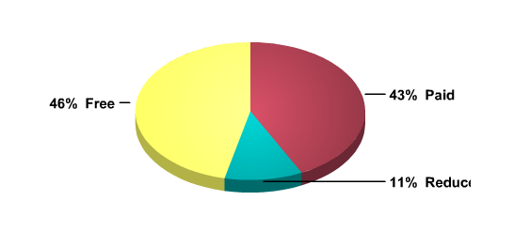
 | Students
Free meals | 233
Reduced price meals | 55
Paid meals | 214

Northridge Middle School, North Montgomery Crawfordsville School Corproation

Median income: $40,867 in 2008 (State: $42,743)

School Enrollment 2009-10: 475
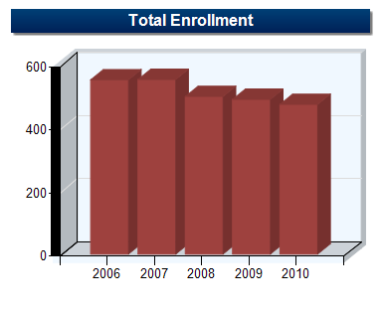
 | 2006 | 2007 | 2008 | 2009 | 2010
Grade 6 | 189 | 185 | 136 | 163 | 170
Grade 7 | 184 | 186 | 185 | 144 | 158
Grade 8 | 180 | 183 | 179 | 184 | 147
Total | 553 | 554 | 500 | 491 | 475

Ethnicity 2009-2010

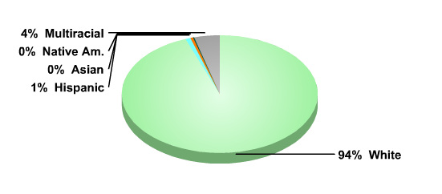
 | Students
American Indian | 1
Asian or Pacific Islander | 2
Hispanic | 4
White | 449
Multiracial | 19
Free/Reduced Lunch Information 2009-10

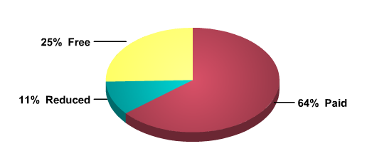
 | Students
Free meals | 121
Reduced price meals | 50
Paid meals | 304

Frankfort Middle School, Community Schools of Frankfort

Median income: $38,318 in 2008 (State: $42,743)

School Enrollment 2009-10: 722
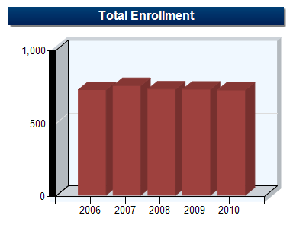

 | 2006 | 2007 | 2008 | 2009 | 2010
Grade 6 | 236 | 262 | 240 | 239 | 255
Grade 7 | 248 | 246 | 254 | 234 | 232
Grade 8 | 240 | 244 | 234 | 254 | 235
Total | 724 | 752 | 728 | 727 | 722

Ethnicity 2009-2010
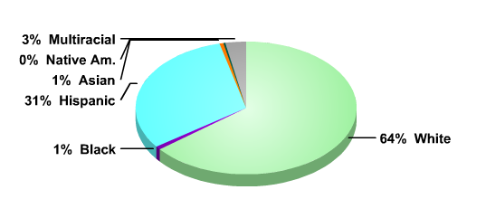
 | Students
American Indian | 2
Black | 6
Asian or Pacific Islander | 4
Hispanic | 224
White | 463
Multiracial | 23

Free/Reduced Lunch Information 2009-10

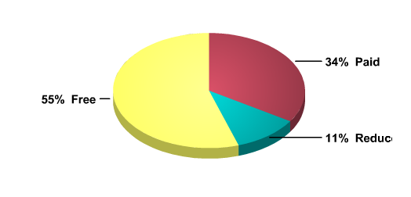
 | Students
Free meals | 397
Reduced price meals | 80
Paid meals | 245

Wabash Middle School, Wabash City Schools

Median income: $39,613 in 2008 (State: $42,743)

School Enrollment 2009-10: 502
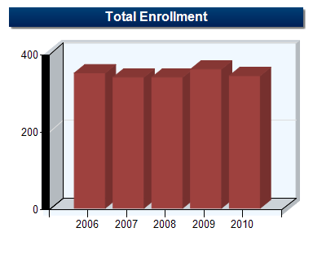
 | 2006 | 2007 | 2008 | 2009 | 2010
Grade 6 | 98 | 115 | 116 | 123 | 99
Grade 7 | 124 | 102 | 119 | 122 | 121
Grade 8 | 127 | 121 | 103 | 114 | 122
Total | 349 | 338 | 338 | 359 | 342

Ethnicity 2009-2010
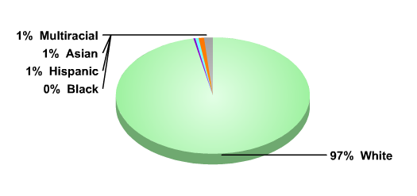

 | Students
Black | 1
Asian or Pacific Islander | 3
Hispanic | 2
White | 331
Multiracial | 5

Free/Reduced Lunch Information 2009-10

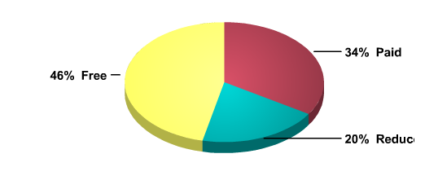
 | Students
Free meals | 159
Reduced price meals | 67
Paid meals | 116

B. Comparison Data for Participating
Schools and State Averages

By ISTEP Science Grade 7

Note: Scores for the ISTEP Science Grade 7 data included as data is not available for Grade 6 Science.

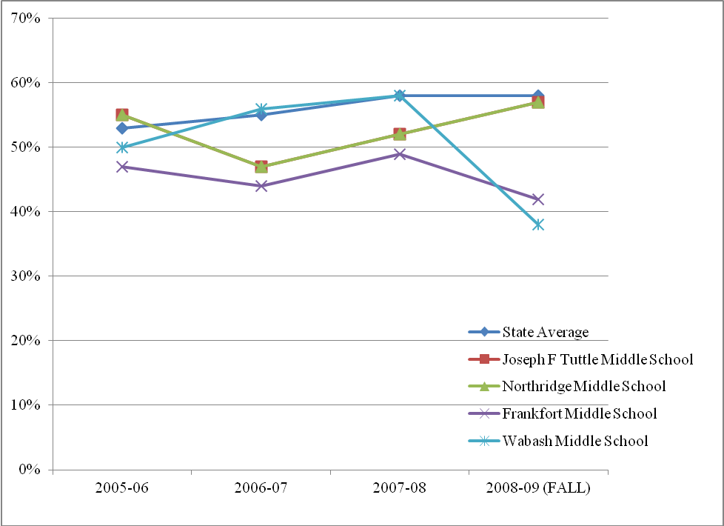

 | ISTEP Science Grade 7
Year | State Average | Joseph F Tuttle Middle School | Northridge Middle School | Frankfort Middle School | Wabash Middle School
2008-09 (FALL) | 58% | 57% | 57% | 42% | 38%
2007-08 | 58% | 52% | 52% | 49% | 58%
2006-07 | 55% | 47% | 47% | 44% | 56%
2005-06 | 53% | 55% | 55% | 47% | 50%

By ISTEP Math Grade 6

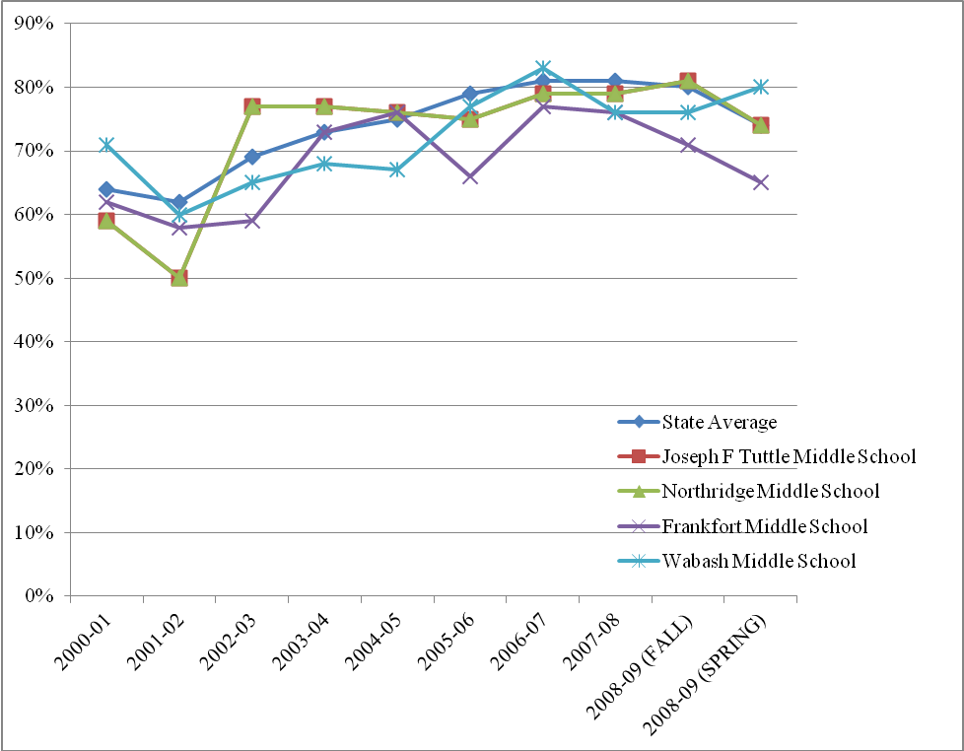

 | ISTEP Math Grade 6
Year | State Average | Joseph F Tuttle Middle School | Northridge Middle School | Frankfort Middle School | Wabash Middle School
2008-09 (SPRING) | 74% | 74% | 74% | 65% | 80%
2008-09 (FALL) | 80% | 81% | 81% | 71% | 76%
2007-08 | 81% | 79% | 79% | 76% | 76%
2006-07 | 81% | 79% | 79% | 77% | 83%
2005-06 | 79% | 75% | 75% | 66% | 77%
2004-05 | 75% | 76% | 76% | 76% | 67%
2003-04 | 73% | 77% | 77% | 73% | 68%
2002-03 | 69% | 77% | 77% | 59% | 65%
2001-02 | 62% | 50% | 50% | 58% | 60%
2000-01 | 64% | 59% | 59% | 62% | 71%

By ISTEP English/LA Grade 6

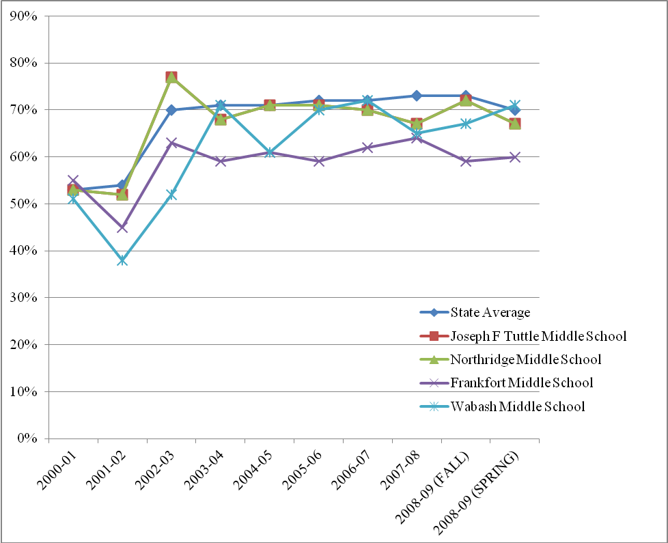

 | ISTEP English/LA Grade 6
Year | State Average | Joseph F Tuttle Middle School | Northridge Middle School | Frankfort Middle School | Wabash Middle School
2008-09 (SPRING) | 70% | 67% | 67% | 60% | 71%
2008-09 (FALL) | 73% | 72% | 72% | 59% | 67%
2007-08 | 73% | 67% | 67% | 64% | 65%
2006-07 | 72% | 70% | 70% | 62% | 72%
2005-06 | 72% | 71% | 71% | 59% | 70%
2004-05 | 71% | 71% | 71% | 61% | 61%
2003-04 | 71% | 68% | 68% | 59% | 71%
2002-03 | 70% | 77% | 77% | 63% | 52%
2001-02 | 54% | 52% | 52% | 45% | 38%
2000-01 | 53% | 53% | 53% | 55% | 51%

Since the dependent data was not normally distributed non-parametric tests needed to be conducted in the analyses.
Effect size can be judged on the basis of Cohen (1988) criteria of .1= small effect, .3=medium effect, and .5=large effect (as cited in Pallant, 2007, p. 223). Full reference for this book is Pallant, J. (2007). Survival manual: A step by step guide to data analysis using SPSS for windows (3rd edition). England: Open University Press.
T stands for “Teacher”.
S stands for “School”.
Manual for the Patterns of Adaptive Learning Scales, University of Michigan, 2000, p. 12.
Manual for the Patterns of Adaptive Learning Scales, University of Michigan, 2000, p. 13.

