Kadir Kozan
Learning, Design and Technology
Purdue University
kkozan@purdue.edu

Traditional books versus e-books: Which one fosters better learning on what type of comprehension questions?
Abstract or Synopsis
This study is aimed at comparing learning from traditional books to learning from e-books using an expository history text. The purpose was to achieve this comparison based on the type of comprehension questions directed to 18 participants: true or false, multiple choice, open ended, fill-in-the blanks. The participants were randomly assigned to either reading from a traditional book or from an e-book group. The e-books used in the present study were presented on iPads. Time on learning was 2 hours and kept constant across the groups. The participants were asked not to use such learning strategies as highlighting, note taking as much as possible in order to not to create contaminating factors. Results revealed no learning differences between the book and e-book experimental groups as based on all type of comprehension questions.

Keywords: Tradition books, e-books, reading, content area
Basic Questions to Reflect Upon (General and study-specific)
- What is learning? (Birkenholz, 1999)
- What is comprehension in the sense of retention and transfer? (Mayer, 2001; 2009).
- How do they connect to memory? (Baddeley, 1992; 2003; Bartlet, 1932: Cowan, 2001; Miller, 1956 )
- How do you read to learn? (Anderson, 2010)
- How do we measure comprehension? Can the results differ based on the type of question(s) employed? (Brantmeier, 2005)
- How differently would e-books and traditional print books affect reading comprehension? (Jones & Brown, 2011)

The present study
Brief Background:
Brantmeier (2005): 1) Each test type (MC, T/F etc.) provides a limited profile of reading comprehension. So:
2) For generalizability reasons, different types of comprehension tasks are necessary
3) Written free recall: tester interference and retrieval cues are minimum, recall, retrieval failure
4) Sentence completion/fill in the blanks: tester, retrieval cues to some extent, recall, retrieval failure
5) MC/T or F: tester, retrieval cues, chance factor, recognition

Main research question:

What are the effects of presentation mode (e-books vs. print books) and question type on retention comprehension from an expository history text?

Hypotheses:
- Given the self-pace nature of the learning environment: There would not be a significant performance difference between presentation modes (book vs. e-book).
- There would be significant performance differences among types of comprehension questions. Specifically: TF>MC>FILL>OE.
- Given the self-pace nature of the learning environment:
There would not be a significant combined effect of presentation mode and type of comprehension questions.

Methods:
- Pre-test – Post-test control group
- Groups were equal on:
- Pre-test scores
- Familiarity with technology
- Enjoying reading in general
- Enjoying reading history books
- Enjoying reading about Civil War
- Difficulty of reading
- Enjoying learning about US history

Findings:
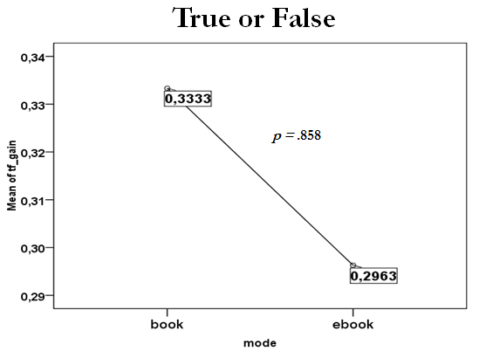
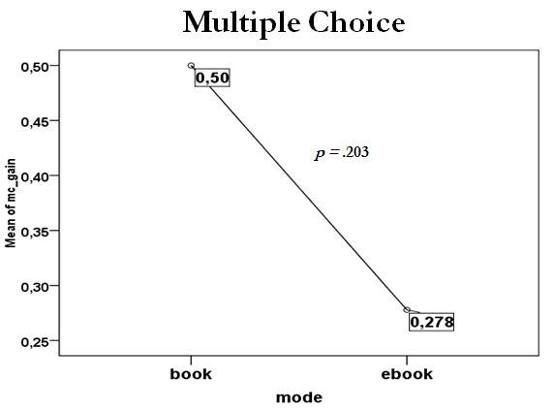

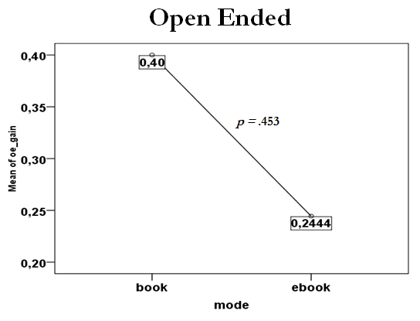
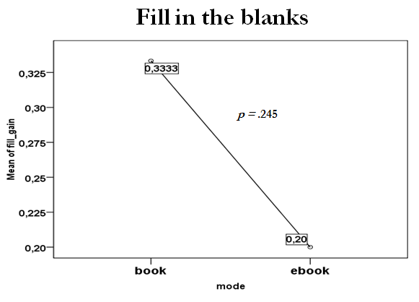
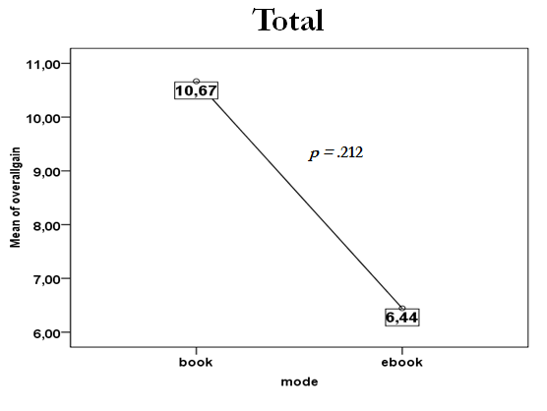
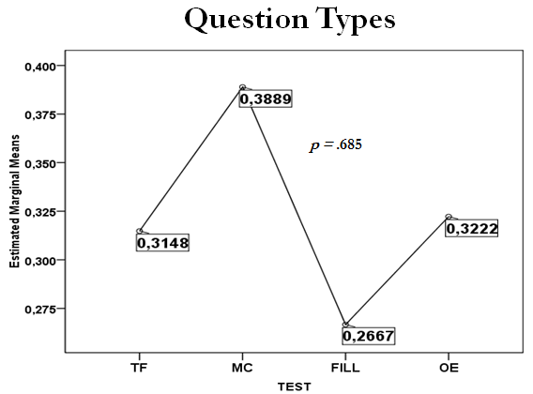
Main Implication:
- Traditional books might be as effective as e-books under such conditions. As such, comparison of learning from e-books vs. print books might be vulnerable to such extraneous variables as reading time, strategies used etc.
- This may be important since development of e-books is more expensive than traditional books especially when scaffolding is integrated.

A very important word of caution:
Need more and more participants… All observed power values were < .8

References and Other Resources

Anderson, J. R. (2010). Cognitive psychology and its implications (7th ed.). New York, NY: Worth Publishers.
Baddeley, A. (1992). Working memory. Science, 255, 556-559.
Baddeley, A. (2003). Working memory and language: an overview. Journal of Communication Disorders, 36, 189-208.
Birkenholz, R. J. (1999). Effective adult learning. Danville, USA: Interstate Publishers.
Bartlett, Frederic C. 1967. (1932). Remembering: A study in experimental and social psychology. London: Cambridge University Press.
Brantmeier, C. (2005). Effects of readers` knowledge, text type, and test type on L1 and L2 reading comprehension in Spanish? The Modern Language Journal, 89, 37-53.
Cowan, N. (2001). The magical number 4 in short-term memory: A reconsideration of mental
storage capacity. Behavioral and Brain Sciences, 24, 87-185.
Jones, T., & Brown, C. (2011). Reading engagment: A comparison between ebooks and traditional print books in an elementary classroom. International Journal Of Instruction, 4(2), 5-22.
Mayer, R. E. (2001). Multimedia learning. New York: Cambridge University Press.
Mayer, R. E. (2009). Multimedia learning (2nd ed.). New York: Cambridge University Press.
Miller, George A. (1956). The magical number seven, plus or minus two: Some limits on our
capacity for processing information. Psychological Review, 63, 81-97. Retrieved
from http://psychclassics.yorku.ca/Miller/
PBS Nova Science. (2009, August). How memory works. Retrieved from http://www.pbs.org/wgbh/nova/search/results/?q=how+human+memory+works&x= 0&y=0

