Task Analysis
In order to build out task analysis we went through the electromagnets content sheet we got from EPICS team. This was an interesting experience in that we had to deal with a topic or lesson on which we did not have too much prior knowledge. Based on the content, we decided that this was a sort of principle learning including concepts as well ranging from an electromagnet to circuits. We also took into account the fact that learning experience would be online and would be achieved on the computer. Consequently, our first task analysis included such basic computer skills as connecting to the WWW, navigation and the like. Assuming that our learners would need to take notes down while working through module, we decides to insert “basic note taking” skills at the bottom of our first task analysis as one of the main prerequisite steps. Because we agreed that our module would also include learning of some concepts, some vocabulary possibly related to these concepts would have also been learned, thus constituting another basic step at the bottom of our tasks analysis.
These basic steps gave path to the second-order ones that would be called “description and identification of the basic concepts and phenomena related to electromagnets. Needless to say, these constituted the lowest level of Bloom`s taxonomy: knowledge. The next step involved tapping learners` prior knowledge on magnets and connecting it to electromagnets. At this point, the task analysis required learners to compare and contrast concepts + principles that related to magnetism and electromagnetism. Since we hypothesized that points covered so far were also essential for the hands-on experiments, our tasks analysis branched into another main area: experimenting on electromagnets which include building an electromagnet. Accordingly, we assumed synergistic activities between these two main parts that would relate the parts in question to each other. Based upon these, we envisioned that learners would move on to relating electromagnets to both electric motors and electric cars. The figure on the next page depicts the first task analysis:

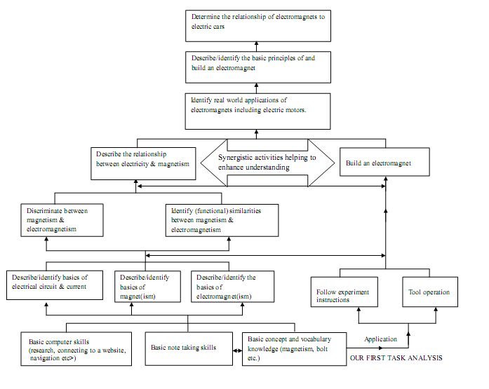
While building the task analysis above, we also reflected on the flow of our module: how to start, how to orient and motivate etc. Doing this while building the task analysis was very beneficial for two basic reasons: 1) it was clearer to see or build connections between types of activities we wanted to insert into our module and information steps included in the task analysis, and 2) it really helped us to gauge whether what we included in our task analysis was “doable’ through activities. The list of these is as follows:
1) Basic concept and vocabulary knowledge would be a prerequisite for students to understand the concepts covered in the learning module and the relationships among them (i.e., principles). Therefore, on the basis of the pretest, the learning module may include some sort of concept learning. Then, the remaining decision is whether this will be an inquiry approach or an expository approach located before beginning to learn the principles or embedded into learning principles themselves.

2) The possible range of concepts would include:
Magnet, electricity, electrical circuit, current, electromagnet(ism), strength…Closely related to the concepts, knowledge of the following vocabulary items would be necessary: wire, nail, to wind, washer(s), nut, bolt, sandpaper, wire cutter, power supply, enamel, electrical tape, linear trend, loop.

3) Similar to concept learning a decision has to be made regarding whether an inquiry or expository approach will be implemented in learning of the principle(s).

4) Presentation of concepts and vocabulary items may be enriched through visual materials such as pictures.

5) We need to insert application or do activities in which learners will be asked to engage in practice of the principle(s). What kind of practice need to be included in the online module and to what extent it should be separate from the hands-on experiences need to be determined.

6) Even though hands-on experiments themselves constitute application of the principle(s), it seems we are in need of connect activities that will bridge the online learning module to the hands-on experiments.

Overall electromagnet lesson flow (content/style to be discussed and determined):

- Gaining attention of the learners.
- Establishing and conveying the instructional purpose to the learners.
- Preview of the lesson
- Tapping prior knowledge (acquisition and application of concepts)
- Presenting or processing information (inquiry-based or expository)
- Focusing attention and employing learning strategies (cueing, typography, examples vs. non-examples, etc.)
- Practice
- Stating the principle (declarative knowledge)
- Identifying situations or examples in which principle(s) can be applied.
- Predicting, explaining the relationship among concepts by creating their own examples etc.
- Discriminating correct applications of the principle from the incorrect ones.
- Providing feedback
- A summary or review
- Transfer of knowledge (how the principle(s) can be applied in relation to others or in given situations such as electric cars).
Identifying the relevance or applications or examples of the principle(s) in learners` daily live

Based on the feedback we got, we decided that we included too much at least at the basic level of our task analysis. As a result, we eliminated the basic steps of computer skills and note taking from our task analysis. More importantly, our first task analysis included a step of understanding electromagnetism between relating electromagnets to electric motors and cars. We judged that this did not make sense eliminated this step from this part of the task analysis and inserted it into the experiment branch. Moreover, we eliminated all exhaustive steps of describing and identifying and narrowed it down to properties of electromagnets or electromagnetism. Synergistic activities kept their places on our revised task analysis functioning as a bridge between learning about electromagnets part and hands-on experiments part. In this way, we aimed at encouraging our module to real-life practice of building an electromagnet which would function as an application activity in addition to those that would be included in the online module.
Furthermore, this way of planning about the task analysis also gave us a valuable idea about who to deal with the fact that an online module cannot give a real hands-on experience of building an electromagnet. At this point, we came up with the idea of inserting a video that would show how to build an electromagnet at least in a home environment. Again, chewing on both what to include in the task analysis and who to actualize it in the online module was really helpful to align them with each other as much as possible. The following shows the revised task analysis:

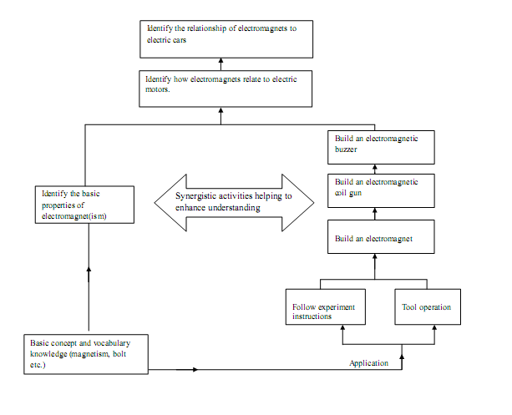

Even though we revised the task analysis, the way we want our module to flow did not change since it followed a basic reasonable pattern from taking attention to transfer of knowledge.
Goals and Objectives:
After the task analysis part, we began setting our main goal and objectives. After creating the task analysis, it was easier to come up with objectives that relate to the steps involved in the task analysis. Our main goal included description and identification of the basic principles on which an electromagnet works. To come up with this goal, we also examined the Indiana State Department of Education`s website to determine what our learners would already know before learning through our module. We think this was important since we wanted to determine what kind of foundation knowledge we would need to provide at the beginning of our module, thus tapping our learners` prior knowledge, which would make it easier for them to relate what would be learning anew to what they would have already known.
While deciding on our objectives, we also thought about our question types and the question themselves. In other words, while trying to make sure that our objectives are measurable; we also tried to create our questions in order to make sure that we would be measuring each of our objectives. We decided to include multiple pick questions in order to decrease number of questions we would ask and there were more than one answer already. Additionally, we also chewed on feedback type for each correct and incorrect answer and decided to give them the chance to go back and try to answer questions once more. Thinking about such details and taking notes down about them even quite early from starting to build the online module helps a lot in terms of which direction to go.
Target learners and context:
The target learner group was middle school 6 to 8th graders who would be involved in learning about how build and drive an electric car. Even though our part was smaller in terms of scope compared to the whole of the lesson, we also paid attention to tacit aim of promoting students` understanding of science and engineering and how to bring them together. This was challenging though since there was another independent module focusing on that issue. The challenge basically stemmed from paying continuous attention to trying to keep a balance between whether our module would look a science unit or an engineering unit. After all, even though most of the information included is scientific, engineers need to have at least a general idea about all this information in order to do their jobs.
Furthermore, we did not pay great attention to such contexts aspects as where the learning is assumed to take place (e.g., a computer lab or at home) or how it is assumed to take place (e.g., group work or individual study). However, our activities and the type of interactivity we put into our module are much more individual. For instance, we ask them to type in their answers into the text boxes for several times, and compare and contrast their answers with the information provided. Even though the compare and compare part can also be done as a group work, typing answers certainly encourages individual work at least at the first glance. However, depending on the context again or whether there would be instructors, of course, all these can also be actualized as a group work as well with the exception that there would be one group member who would be responsible for the typing part while others direct him.
Design and Development
Based on the main points provided on page 3, we tried to design our instruction and to develop our online module. In our words, those points constituted our main instructional strategies. In other words, in addition to our overall learning goal, we had a naive instructional goal consisting of a few parts: take attention of learners, give them reason to go through our module, connect new learning material to their any possible relevant prior knowledge, demonstrate, let them apply and involve in the learning process (make it as much interactive as possible) evaluate end give live feedback immediately to turn the evaluation part itself into a learning chance (increase washback effect). Hence, even thought the analysis part of the creation of our module did not include the analysis of learners` existing knowledge or skills etc. it included the identification of the instructional problem or need, and instructional and learning goals as well as relevant instructional objectives. The first page or activity of our module was one of the most difficult ones to design and then develop. This was the case since the opening activity would give learners the first impression about our learning module. Even before actual development of the module in the form of web pages, during paper prototype sessions, this was a big concern for us. Given the grade levels of our target audience, we thought this would be pivotal. In what follows, the current report presents the screen shots from each of the web page of our “electromagnets” module together with design and learning related comments.

